**A positive feedback loop of circRRM2-IGF2BP1-MYC promotes breast cancer metastasis**

Ran Hao†, Lei Zhang†, Yangming Si†, Peng Zhang, Yipeng Wang, Bangchao Li, Jie Hu*, Yixin Qi*

Correspondence:

Jie Hu (Hujie@hebmu.edu.cn) and Yinxin Qi (13932153600@139.com)

†These authors have contributed equally to this work.

Abstract

Key word: circular RNA; breast cancer; metastasis; feedback loop; MYC

**1. Introduction**

As the most prevalent type of cancer in women, breast cancer (BC) is the leading cause of cancer-related mortality among women worldwide. Although notable progress with regard to early diagnosis and comprehensive treatment strategies has improved the prognosis of patients with BC, the morbidity and mortality are still increasing. Importantly, metastasis is the major cause of mortality in breast cancer. Nevertheless, little is known about the underlying mechanism by which the invasive capability of cancer cells is enhanced in BC progression, which might provide the novel therapeutic strategies for patients with metastatic BC. Over the last few years, substantial evidence has revealed that noncoding RNAs (ncRNAs), including circular RNAs (circRNAs), are involved widely in BC progression.

circRNAs, characterized by covalently closed loop structures without 5′-cap structure and 3′-polyadenylated tail, are highly conserved and stable. circRNAs are derived from precursor mRNA back-splicing or skipping events throughout the eukaryotic genome. Growing evidence has shown that circRNAs may contribute to the regulation of various biological processes such as transcriptional regulation, protein translation, and immune regulation. CircRNA functions through a variety of ways, such as serving as competing endogenous RNA (ceRNA), interacting with proteins, and being translated to proteins. Recently, an increasing number of circRNAs have been reported to be associated with the malignant behavior in BC. For instance, circSEPT9 was increased in TNBC tissues, which was positively correlated with advanced clinical stage and poor prognosis [PMID: 32264877]. Moreover, it has been identified circPTCH1 as a potential prognostic and predictive molecule for BC patients, as it enhanced the malignant progression of BC cells via regulating the autophagic level [PMID: 32213200]. However, roles and mechanisms of circRNAs in BC have not been explored comprehensively.

In the present study, we performed high-throughput circRNA microarray sequencing, and identified a set of distinct circRNAs in individuals with BC. A novel circRNA circRRM2 (hsa_circ_0052582) was identified, which originated from exons 6, 7, 8, and 9 of the RRM2 gene, and circRRM2 was significantly upregulated in BC cell lines and BC tissues. Through functional gain and loss experiments, we observed that circRRM2 promoted BC cells migration and invasion. We also verified a targeted regulatory correlation among circRRM2, miR-31-5p/miR-27-3p and insulin-like growth factor 2 mRNA-binding protein 1 (IGF2BP1) through bioinformatics analysis and cellular experiments. Moreover, IGF2BP1 promoted BC cells migration and interacted with MYC, which functioned as the transcription factor of circRRM2. These findings demonstrated that circRRM2/IGF2BP1/MYC formed a positive feedback loop and facilitated the invasion behavior of cancer cells, suggesting the potential target for the treatment of BC.

**2. Materials and Methods**

**2.1 Patients and samples**

A total of 47 paired human BC and noncancerous tissues were collected between 2017 and 2021 at The Fourth Hospital of Hebei Medical University. Specimens were immediately snap-frozen after surgical removal and stored at -80 °C until RNA extraction. Seven of them were for circRNA expression proﬁle analysis. This study was approved by the Ethical Committee of The Fourth Hospital of Hebei Medical University, and written informed consent was obtained from all patients (approval ID: 2019MEC067).

**2.2 CircRNA microarray and computational analysis**

circRNA expression proﬁle of seven pairs of human BC tissues and noncancerous tissues were analyzed using Arraystar Human circRNAs arrays (ArrayStar, Rockville, MD, USA), which contains 5396 probes specific for human circular RNAs backsplice junction region. The circRNA microarray analysis was performed by Shanghai Biotechnology Corporation (Shanghai, China). Quantile normalization and subsequent data processing were performed using the R software package. We used threshold values of ≥2 (or ≤−2)-fold change and an adjusted *P* value <0.05. To validate the expression level of circRNAs, we obtained the circRNA dataset GSE111504 of BC from the GEO database. The criteria for gene screening were |Log FC| >2 and adjusted *P* value <0.05. Principal component analysis (PCA) was performed to indicate circRNAs with the greatest impact on discrimination between BC and non-BC (NT) tissue samples using the R package FactoMineR.

**2.3 Bioinformatics analysis**

The parental gene of differentially expressed circRNA in BC were analyzed their potential biological roles through gene ontology (GO) analysis and Kyoto Encyclopedia of Genes and Genomes (KEGG) pathway analysis. A false discovery rate (FDR) of< 0.05 was considered for a significant GO function and KEGG pathway.

The sequence of hsa_circ_0052582, hsa_circ_0058113, hsa_circ_0058148, and hsa_circ_0060551 was acquired from circBase. To predict the potential miRNAs binding with the four circRNAs, we used five online analysis tools: Circbank database, miRanda, TargetScan, CircInteractome and the cancer-specific circRNA database. The downstream target genes of top miRNAs were predicted using TargetScan, miRanda, and miRWalk 2.0. The final circRNA-miRNA-mRNA network graphs were constructed and visualized using Cytoscape v3.5.1. The websites linking to the above online databases are listed in Table S2.

We performed the single sample GSEA (ssGSEA) to analyze the immune infiltration for 24 types of immunocytes in BC between IGF2BP1-high and IGF2BP1-low expression group, using GSVA package in R ([http://www.bioconductor.org/packages /release/bioc/html/GSVA.html](http://www.bioconductor.org/packages%20/release/bioc/html/GSVA.html)). The correlation analysis between IGF2BP1 status of copy number variation and immunocytes infiltration in BC patients was conducted using TIMER platform. The prognostic value of tumor-infiltrating immune cells was analyzed using the log-rank test using TIMER. In addition, the specific correlation of IGF2BP1 with key immune checkpoints was also investigated using TCGA-BRCA dataset.

We explored the methylation features related to IGF2BP1 using TCGA-BRCA dataset. The expression level of three DNA methyltransferases was analyzed in IGF2BP1 high and IGF2BP1 low groups. Then, the methylation levels of IGF2BP1 were assessed between the BC and normal tissues utilizing the human disease methylation database DiseaseMeth version 2.0 (<http://bio-bigdata.hrbmu.edu.cn/diseasemeth/>) and UALCAN (http://ualcan.path.uab.edu/). We also explored the association between IGF2BP1 expression level and its DNA methylation status using MEXPRESS (https://mexpress.be). Besides, we analysed the characteristic of missense mutation and PTM sites located in IGF2BP1 in BC samples, using the cBioPortal database.

**2.4 Cell culture**

Normal human mammary epithelial cell line (MCF-10A) and BC cell lines (BT-474, BT-549, MCF-7, MDA-MB-231, MDA-MB-453 and T47D) and were purchased from Procell (Procell Life Science & Technology Co., Ltd., Wuhan, China). The cells were cultured under conditions recommended by the Procell and maintained at 37 °C with 5% CO2 in a humidified incubator.

**2.5 RNA extraction and quantitative real-time reverse transcription PCR (qRT-PCR)**

Total RNA was isolated from the tissue and cells using TRIzol reagent (Life Technologies, Carlsbad, CA, USA), according to the manufacturer’s protocol. RNA was reverse-transcribed using TransScript One-Step gDNA Removal and cDNA Synthesis SuperMix (TransGen, Beijing, China). TransStart Top Green qPCR SuperMix (TransGen, Beijing, China) was used for qRT-PCR. The circRNA and mRNA levels were normalized by β-actin. The miRNA level was normalized by small nuclear U6. All the values were standardized with 2 -ΔΔCT method. Oligonucleotides sequences are listed in Supplementary Table 1.

2.6 WB

Cells were lysed them in RIPA lysis buffer (Solarbio, Beijing, China) supplemented with protease inhibitor (Beyotime, Beijing, China). Total proteins were extracted and separated by 10% SDS-polyacrylamide gel electrophoresis and transferred onto a polyvinylidene difluoride (PVDF) membrane (Millipore, MA, USA). We incubated membranes with 5% skim milk powder at room temperature for one hour to block the nonspecific binding. Then the membrane was incubated overnight with the primary antibody. anti-IGF2BP1, anti-c-Myc and anti-β-actin were purchased from (Proteintech, Wuhan, China). Protein bands were visualized using NcmECL Ultra reagents (New Cell & Molecular Biotech, Suzhou, China) according to the kit’s instruction.

**2.7 RNA interference and plasmid transfection**

siRNAs targeting the back-splice junction of circRRM2, siRNAs targeting the mRNA of IGF2BP1 and MYC were designed and synthesized by GenePharma (GenePharma Corporation, Shanghai, China). The overexpression plasmid of circRRM2 was constructed by inserting sequences of circRRM2 into the pcDNA 3.1vector (Invitrogen, Carlsbad, CA, USA), named as pcDNA-circRRM2, and pcDNA empty plasmid was as a negative control (PMID: 30531834). According to the manufacturer’s protocol, cells were transfected using Lipofectamine 2000 (Invitrogen, Carlsbad, CA, USA). The sequences of siRNAs were shown in Supplementary Table 2.

**2.8 FISH-immunoﬂuorescence microscopy.**

FISH assay was executed to observe the location of circRRM2 and miR-27b-3p in BT-549 cells. The hybridization was performed overnight with has_circ_0052582 and hsa-miR-9-5p probes. Slides were photographed with a fluorescence microscope (Leica, Wetzlar, Germany). The circRRM2 probe for FISH was 5’- CAT TGA AGA GAA ATT CCC TTG CTA AAA CCC -3’ and the hsa-miR-27b-3p probe for FISH was 5’- GCA GAA CUU AGC CAC UGU GGC AGA AC TTA GCC ACT GTG -3’.

**2.9 Wound-healing assay**

Twenty-four hours after transfection, a cell scratch was made in the center of each well using a 200-mL pipette tip. Via wound healing assays, cell motility was assessed by measuring the movement of cells into a scratch. Healing rate (%) was calculated under the formula: (0 h scratch width − 48 h scratch width)/0 h scratch width × 100%. The assays were performed in triplicate.

**2.10 Transwell assays**

Transwell migration and invasion assays were performed using 8-μm pores transwell chambers (Costar, MA, USA) either without Matrigel (for migration assays) or with Matrigel (for invasion assays). 1.2 × 105 /mL infected cells were suspended in 200 μL serum-free medium in the upper chamber, and 500 μL complete medium was added into the bottom chambers. After 24-h incubation, the cells on the upper chambers were removed and cells on the lower compartment were fixed with 4% paraformaldehyde and stained by crystal violet, then imaged and counted with a microscope (Olympus, Tokyo, Japan).

**2.11 RNA immunoprecipitation (RIP)**

RIP assays were performed using the Dynabeads™ Protein G Immunoprecipitation Kit (DMEM, Invitrogen, CA, USA), according to the manufacturers protocol. Antibodies for RIP assays against AGO2 and IgG were purchased from Proteintech (Wuhan, China). The abundance of circRRM2 level was detected by qRT-PCR assay.

**2.12 Co-immunoprecipitation (Co-IP)**

Cells were lysed in NP40 lysis buffer with a protease inhibitor (Solarbio, Beijing, China), RNase inhibitors (Solarbio, Beijing, China) and PMSF (Solarbio, Beijing, China). The lysates were centrifuged at 14,000 × g for 15 min, and the supernatants were collected. The supernatant samples were incubated with IGF2BP1 antibodies or IgG antibodies, combined with Protein A/G magnetic beads (Thermo Fisher Scientiﬁc) at 4 °C overnight with gentle shaking. Immunoprecipitates were eluted by boiling with immunoprecipitation-HA T buffer (50 mM Tris-HCl, pH 8.0, 150 mM NaCl, 5 mM EDTA, 0.5% NP-40, and 0.1 mM PMSF) and subjected to immunoblot analyses.

**2.13 Dual-luciferase reporter assay**

The sequence of circRRM2 was synthesized and subcloned into dual-Luciferase miRNA target expression vector pmirGLO (Promega, WI, USA), and plasmids were validated by sequencing. After 24 h of transfection, the relative luciferase activity was measured by Dual Luciferase Assay Kit (Promega, WI, USA) in accordance with the manufacturer’s protocols.

**2.14 Statistical analysis**

Results are presented as mean ± standard error of the mean (SEM). Statistical analyses were processed using GraphPad Prism 9.0 (GraphPad Software, La Jolla, CA, USA). Student’s t-test, analysis of variance (ANOVA), and chi-square analysis were used to evaluate the difference. The Kaplan-Meier method were used to perform the survival analysis. To evaluate the discrimination ability of target gene, we performed ROC curve analysis using pROC package in LUAD and healthy cases. We included the potential prognostic parameters to construct a nomogram using rms package in R. The nomogram was a prognostic risk scoring system for BC, which could predict the survival probability of BC patients for one year, three years, and five years. Differences were considered statistically signiﬁcant at *P* < 0.05.

**3. Results**

**3.1 Analysis of circRNA microarray profiles in BC**

We collected seven BC specimens and paired paracancerous specimens from untreated BC patients. circRNA microarray were performed to reveal the differences in the expression of circRNA between two groups. The result showed the consistency of BC-related circRNA expression among sample duplicates (Figure 1A). Pearson correlation indicated circRNA expression between BC samples have statistically correlated patterns (Figure 1B). According to PCA method, the samples were split into two groups in the two-dimensional coordinate system, and no outlier samples were detected (Figure 1C). The screening thresholds for circRNA were adjust p-value<0.05 and |logFC| > 2. A total of 1911 dyregulated circRNA candidates were identified in the circRNA microarray, including 1040 upregulated and 871 downregulated circRNAs in BC. The dyregulated circRNA from BC were presented in heatmap (Figure 1D) and volcano-plots (Figure 1G-H). The chromosome distributions of circRNAs with the majority being concentrated on chromosomes 1 and 2 (Figure 1E), and the top parental genes were FN1, CRIM, COL1A, and FANCA (Figure 1F).

Subsequently, we identified four upregulated circRNAs as candidates (hsa_circ_0052582, hsa_circ_0058113, hsa_circ_0058148, and hsa_circ_0060551), according to the median of expression value > 7. The characteristic of their expression value in circRNA microarray was re-analyzed (Figure 2A-B), and their expression between BC samples have statistically correlated patterns (Figure 2C). The PCA results suggested that the expression of the above four circRNAs could distinguish tumor samples from normal samples (Figure 2D).

GO enrichment and KEGG pathway analysis was performed, using the 466 parent genes of the dysregulated circRNAs identified in this study. In Biology Process (BP), genes were mainly enriched in nuclear division and mitotic nuclear division (Figure 2E). In Cellular Component (CC), genes were mainly enriched in spindle and collagen-containing extracellular matrix (Figure 2E). In Molecular Function (MF), genes were mainly enriched in extracellular matrix structural constituent and microtubule binding (Figure 2E). The major KEGG pathways included cell cycle and oocyte meiosis (Figure 2F).

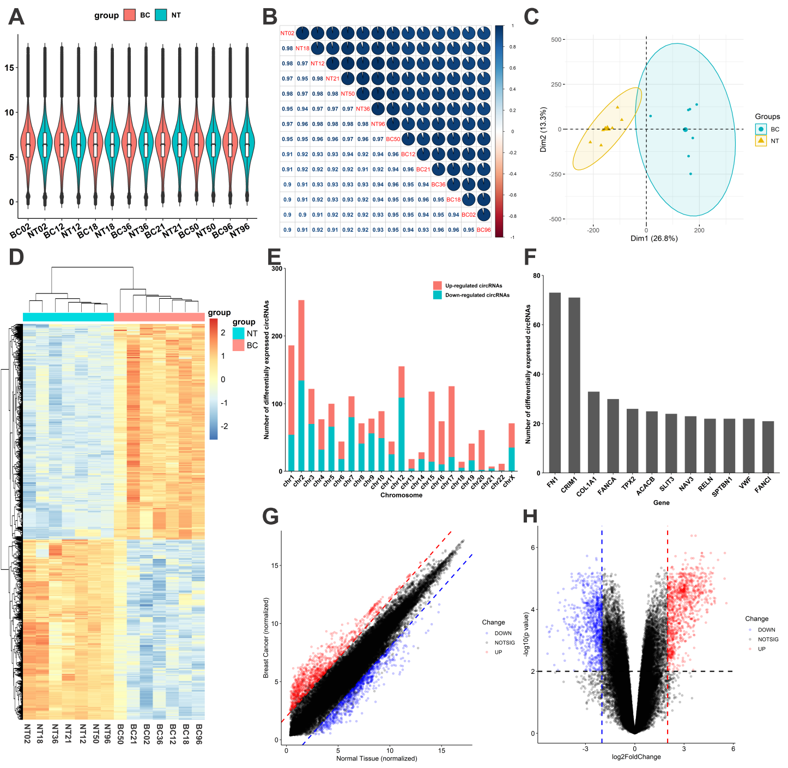

Figure 1 Analysis of circRNA microarray profiles in BC

(A) the consistency of BC-related circRNA expression among BC sample duplicates. (B) The circRNA expression correlation among BC sample duplicates. (C) The PCA analysis between paracancerous specimens and BC specimens. (D) The heatmap of differential expression of circRNA. (E) The location of parent gene of upregulated and downregulated circRNA. (F) The top parent genes of differentially expressed circRNA. (F) The correlations between upregulated and downregulated circRNA. (G) The distribution of the upregulated and downregulated circRNA.

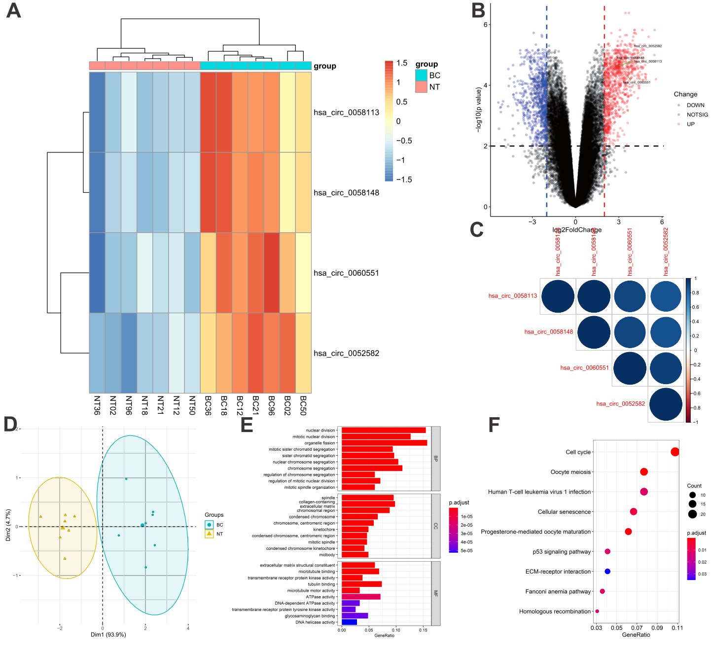

Figure 2 Analysis of four candidate circRNAs and enrichment analysis of parent genes.

(A) The heatmap of differential expression of four candidate circRNAs (hsa_circ_0052582, hsa_circ_0058113, hsa_circ_0058148, and hsa_circ_0060551). (B) The location of four candidate circRNAs in the volcano map. (C) The four candidate circRNAs expression correlation among BC sample duplicates. (D) The PCA analysis of four candidate circRNAs between paracancerous specimens and BC specimens. (E) GO enrichment analysis of parent genes. (F) KEGG enrichment analysis of parent genes.

**3.2 The four candidate circRNAs are upregulated in BC.**

To validate the expression level of the four candidate circRNAs (hsa_circ_0052582, hsa_circ_0058113, hsa_circ_0058148, and hsa_circ_0060551), we collected 40 breast cancer tissues and 40 paired-paracancerous tissues from untreated breast cancer patients. Relative expression levels of the four candidates were determined by qRT-PCR analysis. As shown in Figure 3A-E, the levels of four candidates were significantly upregulated in BC tissues. Patients with a higher level of hsa_circ_0052582 expression had a more advanced N stage (p<0.001, Figure 3E), whereas the other three candidate had no relationship with N stages (Figure 3F-H).

Subsequently, we further confirmed the level of the four candidates and obtained the circRNA expression data from GEO dataset (GSE111504). The results indicated that the expression levels of the four candidates were higher in BC tissues (Figure S1), and were positively associated with advanced T (Figure S2), advanced N (Figure S3) stages. Meanwhile, we extracted total RNA from BC cell lines (BT-474, BT-549, MCF-7, MDA-MB-231, MDA-MB-453, and T47D), and compared the expression levels of the four candidates with normal breast epithelial cells (MCF-10A). The results of qRT-PCR showed that they were upregulated in multiple BC cell lines (Figure 3I-L).

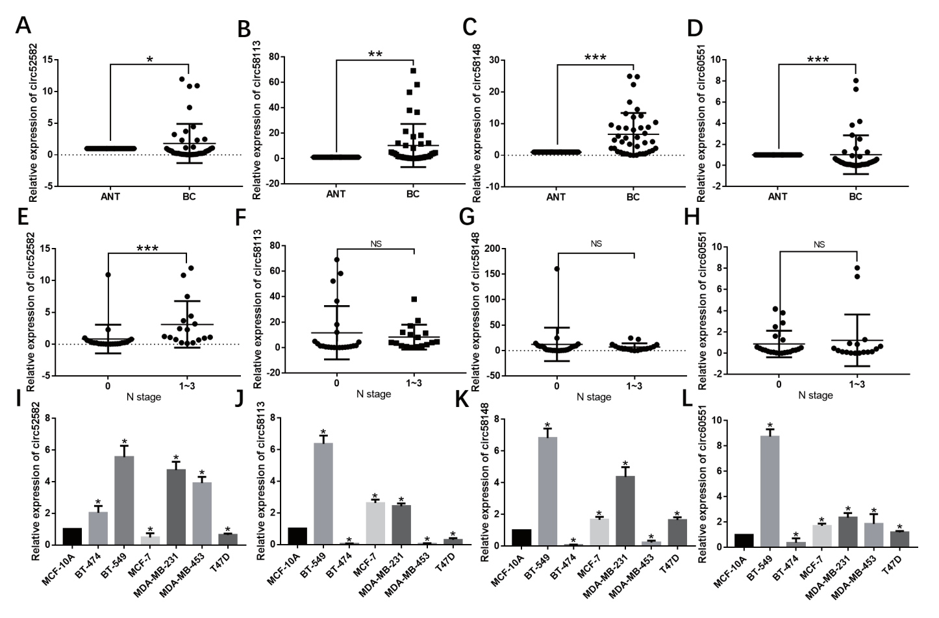

Figure 3. The four candidate circRNAs are upregulated in BC.

Comparison of expression level of hsa_circ_0052582 (A), hsa_circ_0058113 (B), hsa_circ_0058148 (C), and hsa_circ_0060551 (D) between BC tissues and paired-paracancerous tissues. Comparison of expression level of hsa_circ_0052582 (E), hsa_circ_0058113 (F), hsa_circ_0058148 (G), and hsa_circ_0060551 (H) in BC tissues classified by N stage (0 vs. 1-3). Comparison of expression level of hsa_circ_0052582 (I), hsa_circ_0058113 (J), hsa_circ_0058148 (K), and hsa_circ_0060551 (L) between BC cell lines (BT-474, BT-549, MCF-7, MDA-MB-231, MDA-MB-453, and T47D) and normal breast epithelial cells (MCF-10A).

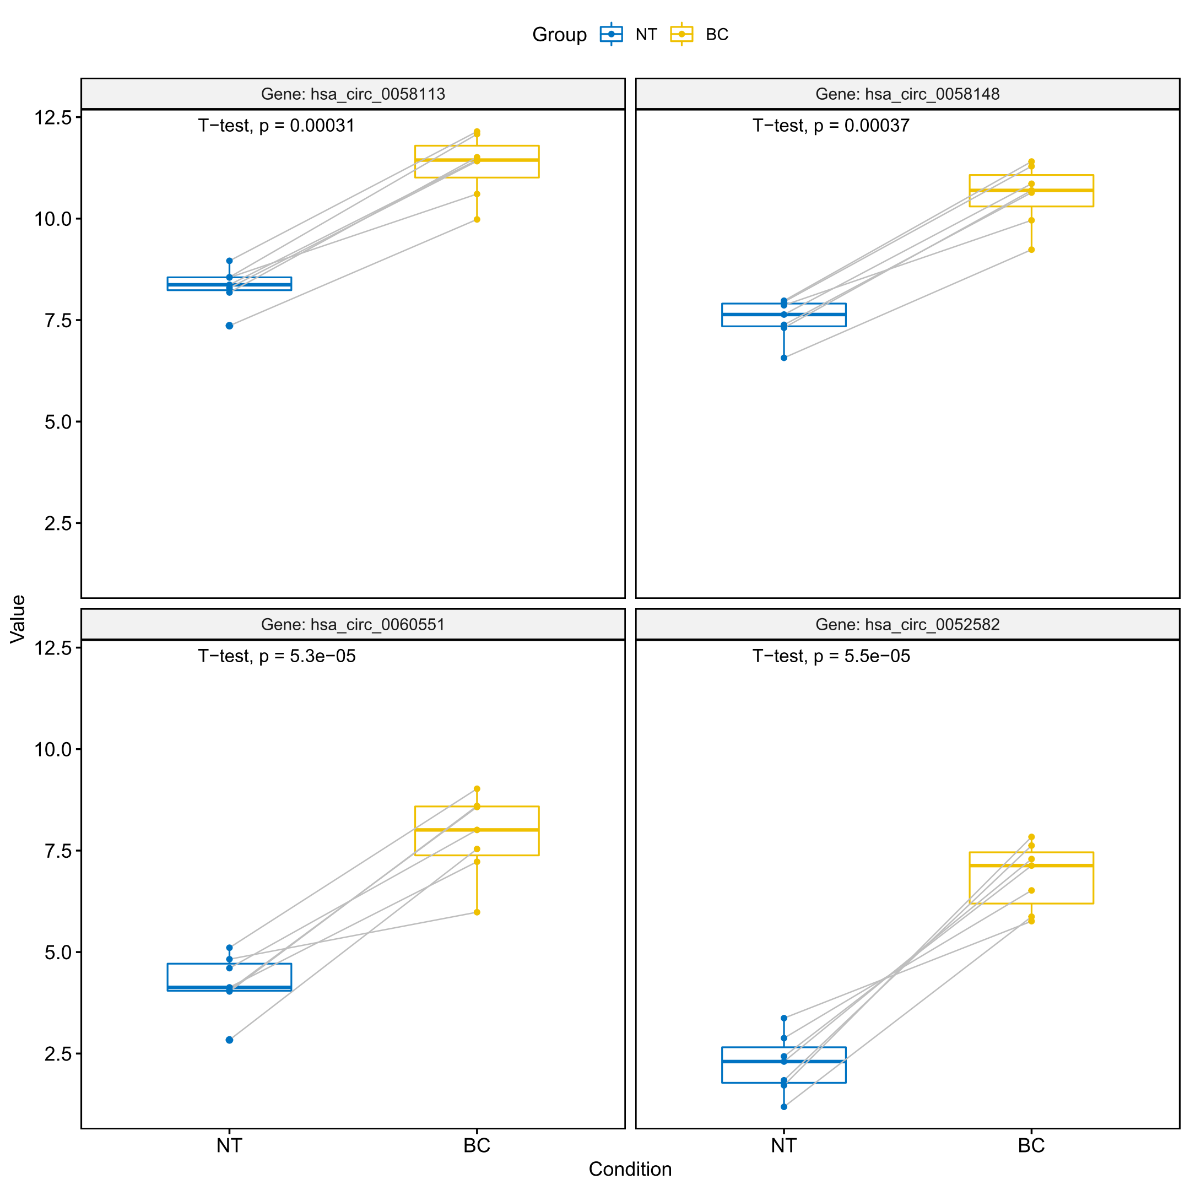

Figure S1. The expression level of hsa_circ_0052582, hsa_circ_0058113, hsa_circ_0058148, and hsa_circ_0060551 in BC patients from GEO dataset (GSE111504).

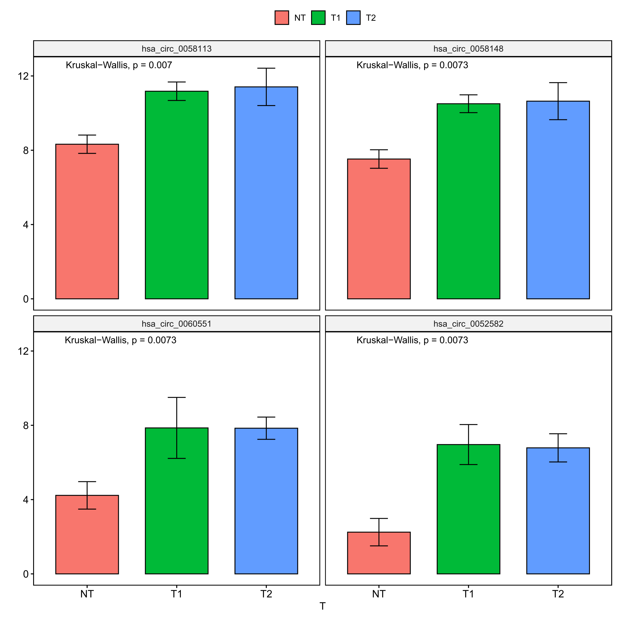

Figure S2. The expression level of hsa_circ_0052582, hsa_circ_0058113, hsa_circ_0058148, and hsa_circ_0060551 in BC patients at different T stage from GEO dataset (GSE111504).

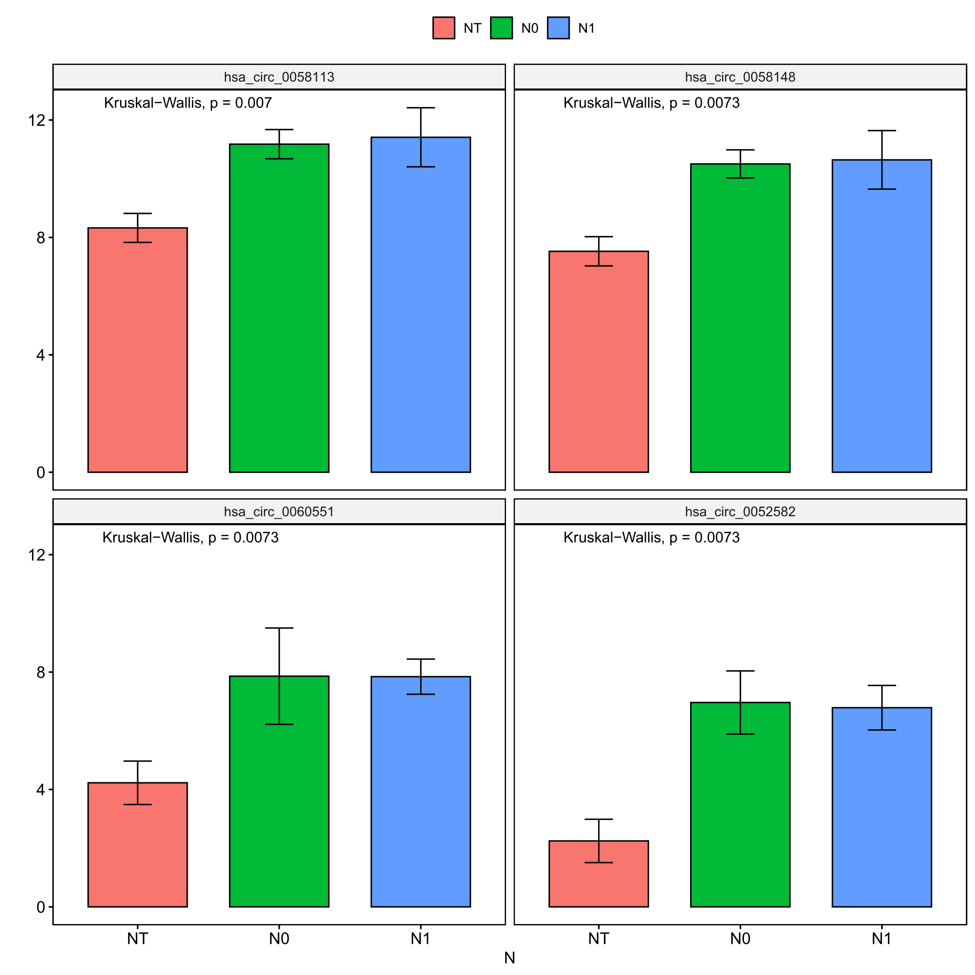

Figure S3. The expression level of hsa_circ_0052582, hsa_circ_0058113, hsa_circ_0058148, and hsa_circ_0060551 in BC patients at different N stage from GEO dataset (GSE111504).

**3.3 The characteristics of the four candidate circRNAs.**

To verify the circular structures of these circRNAs, we designed a set of specific convergent and divergent primers to amplify each circRNA using both cDNA and genomic DNA (gDNA) as PCR templates, respectively (Figure 4A-D). Convergent primers amplified linear CDR1 in both cDNA and gDNA, and divergent primer amplified circRNA in cDNA but not in gDNA (Figure 4A-D). The back-splicing junction site of the four circRNAs was verified by sanger sequencing, respectively (Figure 4A-D), which confirmed their presence additionally. Additionally, we also explored the cellular localization of the four circRNAs after isolating the nuclear and cytosolic fractions. According to the PCR results in MDA-MB-231 or BT-549 cells, hsa_circ_0052582 and hsa_circ_0058113 were detected in both nucleus and the cytoplasm of cells (Figure 4E-F), while hsa_circ_0058148 and hsa_circ_0060551 were predominantly localized in the nucleus (Figure 4G-H).

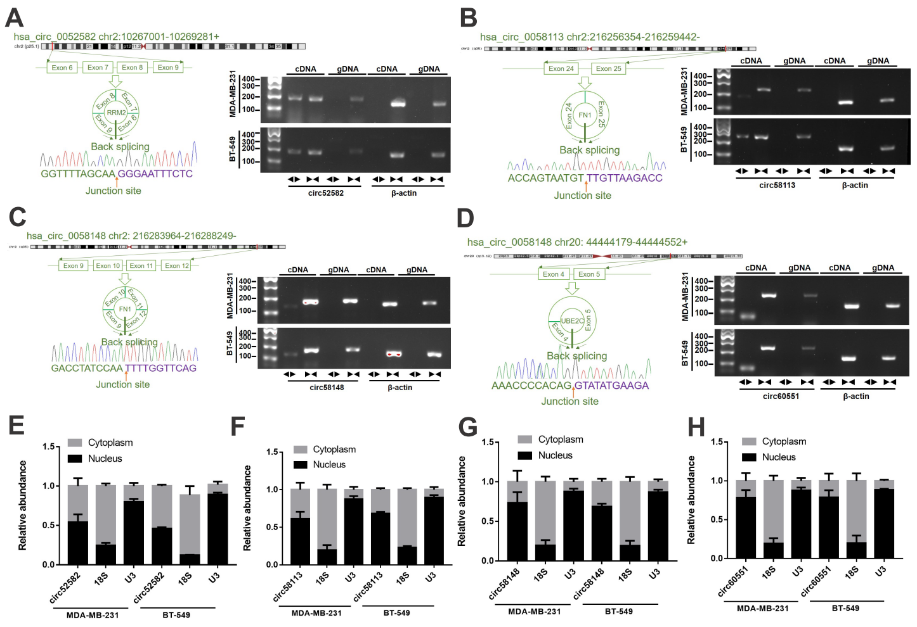

Figure 4. The characteristics of the four candidate circRNAs.

(A-D) Schematic representation of the genomic localization of the four candidate circRNAs, the back-splicing junction sites were verified by sanger sequencing, and electrophoretogram of their PCR products by convergent and divergent primers. (E-H) The cellular localization of the four circRNAs.

**3.4 Construction of circRNA-miRNA-mRNA ceRNA network.**

To better comprehend the role of circRNA in miRNA mediated mRNA, we constructed a circRNA-miRNA-mRNA (ceRNA) network. Firstly, we used five online algorithms, including CircBank database, miRanda, TargetScan v7.1, CircInteractome and Cancer-Specific CircRNA database, to predict the circRNA-bound miRNA. The intersection of the predictions on these five datasets contained 412 miRNAs, and nine hub-miRNAs were identified by further screening (according to their expression level and prognostic value). Subsequently, a total of 8831 target genes of nine hub-miRNAs were predicted by using the TargetScan v7.1, miRanda, and miRWalk 2.0. Based on the expression level and prognostic value, we screened the target genes and determined 537 hub genes. Finally, the circRNA-miRNA-mRNA regulatory network was constructed using Cytoscape software 3.5.1 (Fiugre 5).

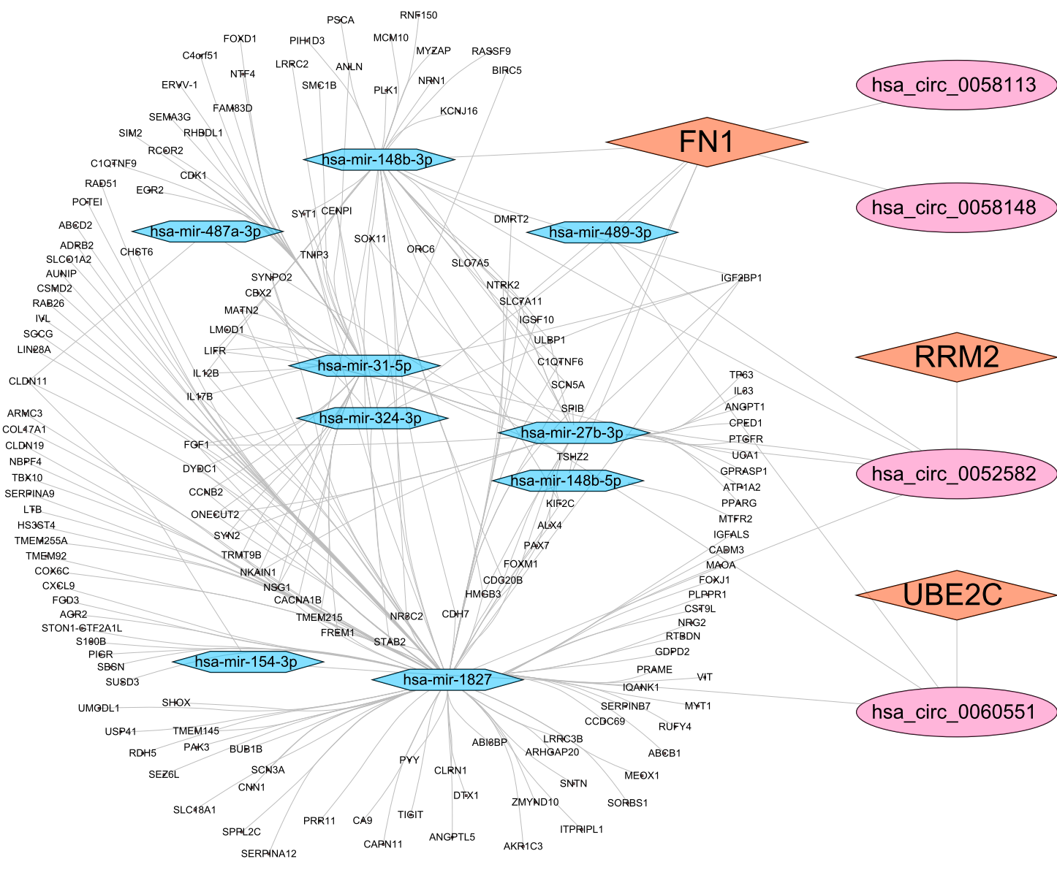

Figure 5. circRNA-miRNA-mRNA ceRNA network.

**3.5 circRRM2 promotes BC cell migration and invasion.**

To investigate the functions of four candidate circRNAs in BC cell migration, the scratch wound healing assay and transwell assay were utilized. We designed the siRNA targeting the back-splicing junction of circRNA (hsa_circ_0052582, hsa_circ_0058113, hsa_circ_0058148, and hsa_circ_0060551), respectively. After transfecting with siRNA, scratch wound healing assay revealed that silencing of hsa_circ_0052582 significantly suppressed cell migration (Figure 6C and 6D). However, down-regulating the other three circRNAs (hsa_circ_0058113, hsa_circ_0058148, and hsa_circ_0060551) had no effect on the cell migration ability. The parent gene of hsa_circ_0052582 is RRM2, thus we name it as circRRM2, which is initially identified. Additionally, transwell assay illustrated that silencing of circRRM2 significantly decreased the BT-549/MDA-MB-231 cell migration and invasion (Figure 6G and 6H). Then, pcDNA3.1-circRRM2 overexpression plasmid was constructed and transiently transfected into BT-549/MDA-MB-231 cells. Conversely, overexpressing circRRM2 remarkably promoted BT-549/MDA-MB-231 cell migration and invasion (Fig. 6A, 6B, 6E and 6F).

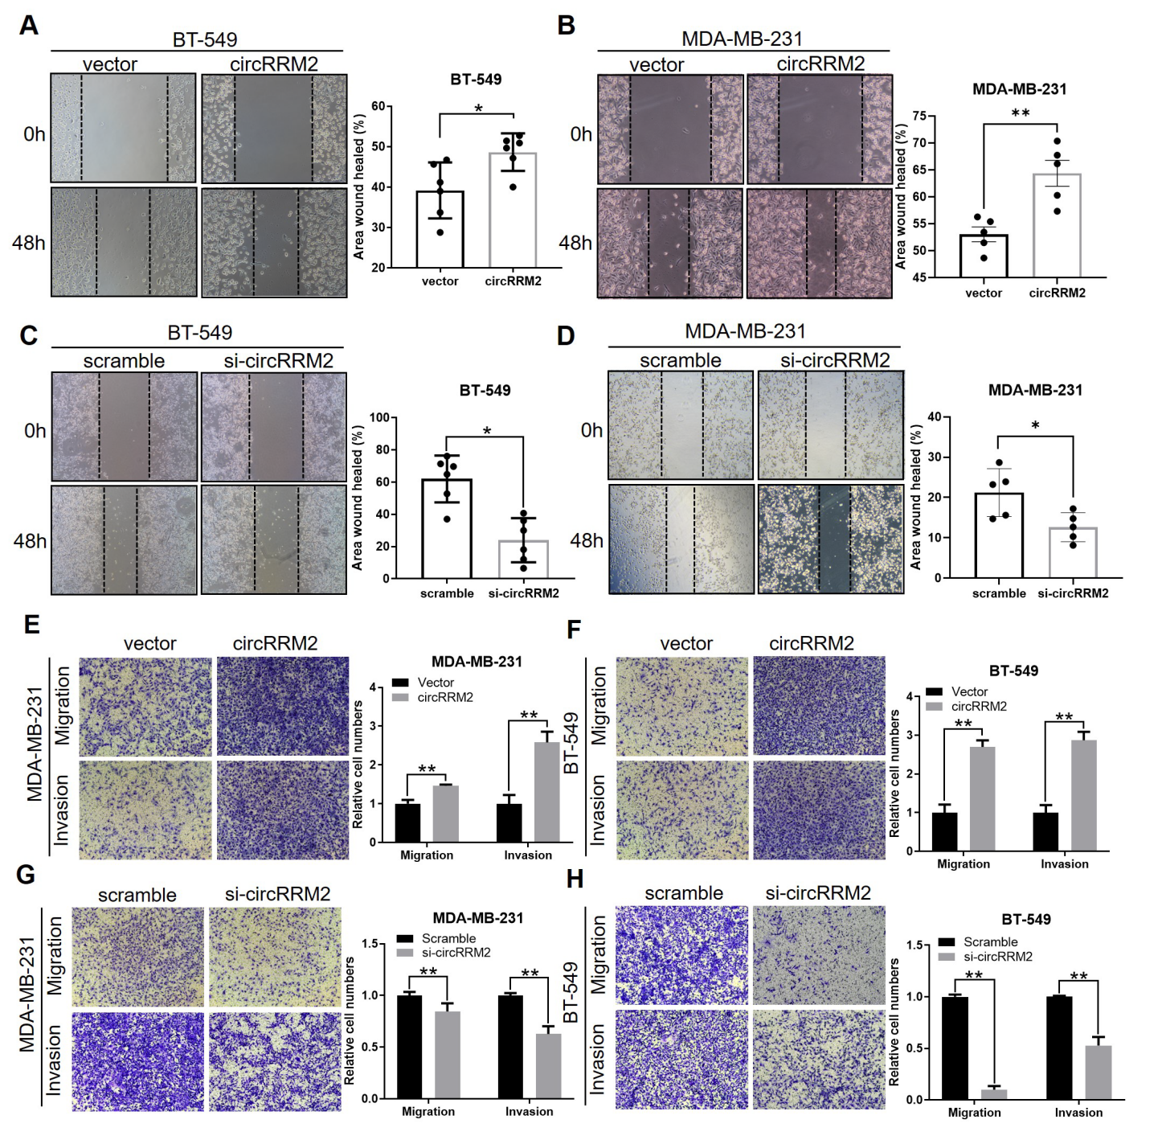

Figure 6. circRRM2 promotes BC cell migration and invasion.

(A-D) Scratch wound healing assays of BC cells with overexpressing or silencing circRRM2. (E-H) Transwell migration and invasion assays of BC cells with overexpressing or silencing circRRM2.

**3.6 circRRM2 serves as a miR-27b-3p/miR-31-5p sponge in BC cells.**

For circRRM2 is localized in both the cytoplasm and nucleus (Figure 4E), we hypothesized that it functioned through the ceRNA mechanism. Ago2 is the core component of RNA-induced silencing complex (RISC), and it could play a central role in the ceRNA mechanism. Thus, we performed RIP experiments using anti‐Ago2 antibody, and the enrichment of circRRM2 was observed (p<0.01, Figure 7A). The result revealed that circRRM2 could function via miRNA binding. Using the RNA22 database, circRRM2 that may interact with miR-27b-3p and miR-31-5p were predicted, and the seed sequence was the longest with nine consecutive nucleotides (Figure 7B). The mRNA level of miR-27b-3p or miR-31-5p was significantly upregulated in circRRM2-knockdown cells (Figure 7C and 7D). The co-localization between circRRM2 and miR-27b-3p was observed in cytoplasm by FISH experiment (Figure 7E). To assess the prognostic value of miR-27b-3p and miR-31-5p expression in BC, we next analyzed its correlation with overall survival using TCGA-BRAC datasets. The KM curves indicated that the low miR-31-5p group was associated with poorer OS (p<0.01, Figure 7G), while miR-27b-3p did not associate with patient prognoses (p>0.05, Figure 7F).

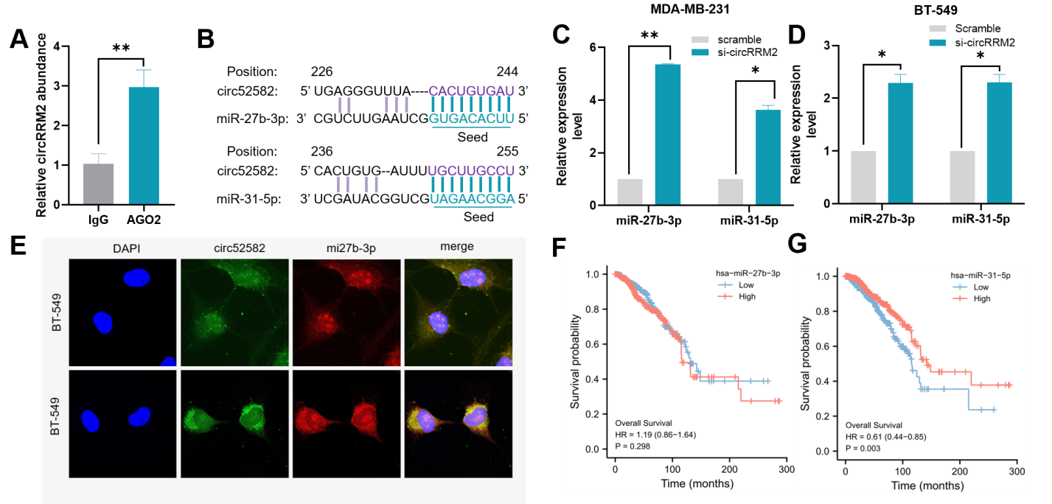

图7 circRRM2 serves as a miR-27b-3p/miR-31-5p sponge in BC cells.

(A) RIP assays using AGO2 antibody for circRRM2 immunoprecipitation. (B) The seed sequences between circRRM2 and miR-27b-3p/miR-31-5p in the RNA22 database. qRT-PCR results of miR-27b-3p/miR-31-5p after circRRM2 knockdown in MDA-MB-231 (C) or BT-549 (D) cells. (E) The co-localization between circRRM2 and miR-27b-3p was observed in cytoplasm by FISH experiment. The prognostic value of miR-27b-3p (F)/miR-31-5p (G) in TCGA-BRCA dataset tested by Kaplan-Meier analysis.

**3.7 circRRM2 facilitates cell migration via miR-27b-3p/miR-31-5p.**

To analyze the effects of miR-27b-3p or miR-31-5p on the malignant phenotypes of BC cells, the scratch wound healing assay and transwell assay were utilized. BT-549/MDA-MB-231 cells were transfected with miR-27b-3p or miR-31-5p mimics, respectively. The results presented that overexpression of miR-27b-3p was able to inhibit both the migration (Figure 8A-B, E-F) and the invasion (Figure 8E-F) ability of BC cells. Conversely, in the miR-27b-3p-inhibitor-transfected cells, the migration phenotype enhanced (Figure S4A). Consistently, overexpression of miR-31-5p inhibited cell migration and invasion (Figure 8C-D, G-H). while miR-31-5p knockdown promoted cell migration (Figure S4B).

In order to further elucidate whether circRRM2 may regulate BC cells migration and invasion through miR-27b-3p or miR-31-5p, rescue experiments were carried out in this study. By scratch wound healing assay, we showed that the overexpression of circRRM2 rescued the migration of cells transfected with miR-27b-3p mimics (Figure 8A-B). circRRM2 overexpression also partially reverses malignant phenotypes of BC cells by Transwell migration and invasion assays (Figure 8C-D, G-H). Meanwhile, circRRM2 knockdown abolished the suppression of cell migration treated with miR-27b-3p inhibitor. Similar results were obtained when we knocked down both circRRM2 and miR-31-5p simultaneously in BT-549 cells (Figure S4B).

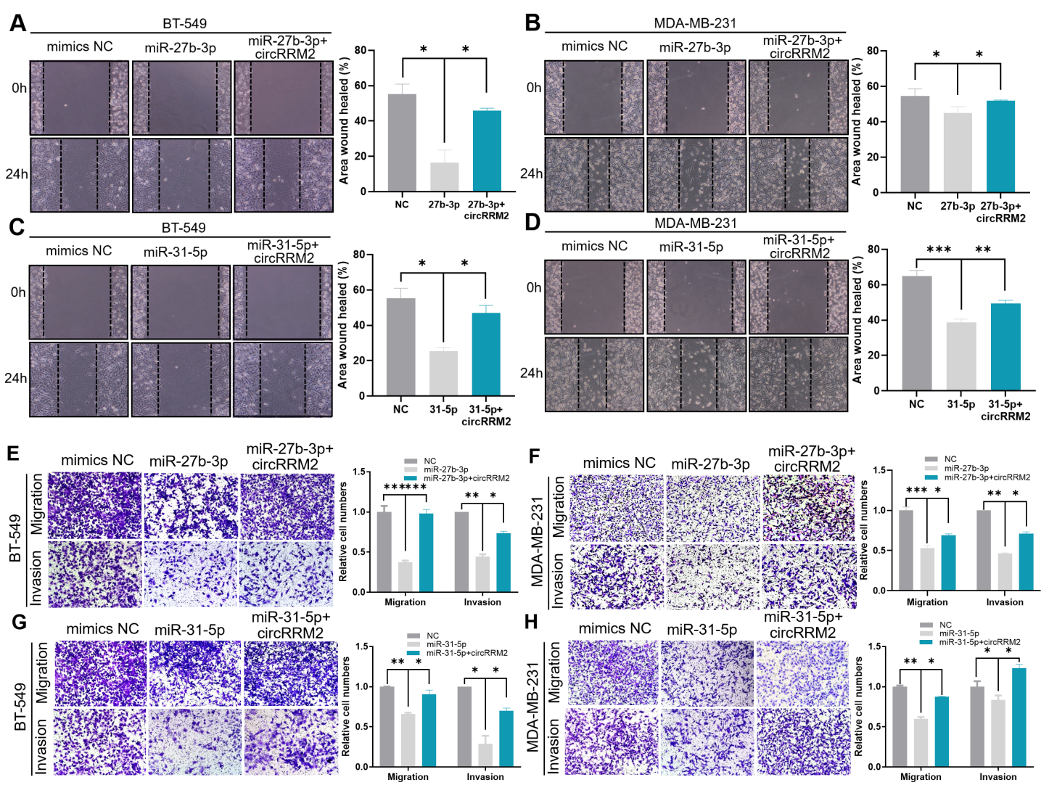

Figure 8. circRRM2 facilitates cell migration via miR-27b-3p/miR-31-5p.

BT-549/MDA-MB-231 cells were transfected with miR-27b-3p (A/B) or miR-31-5p mimics (C/D), or combining with circRRM2 overexpression. The scratch wound healing assay was performed to measure the ability of cell migration. The transwell assay was conducted to observe the cell migration/invasion when cells were transfected with miR-27b-3p (E/F) or miR-31-5p mimics (G/H), or combining with circRRM2 overexpression.

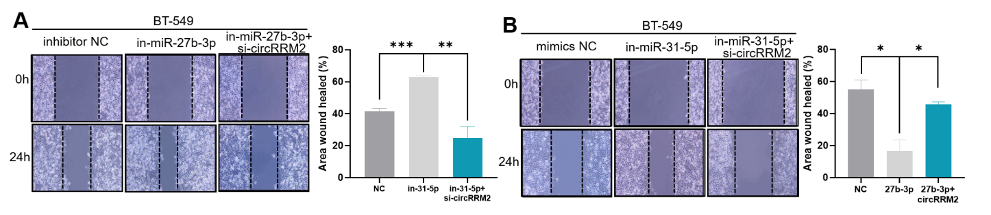

Figure S4. circRRM2 knockdown abolished the suppression of cell migration treated with miR-27b-3p/miR-31-5p inhibitor.

BT-549 cells were transfected with miR-27b-3p (A) or miR-31-5p (B) inhibitor, and the scratch wound healing assay was performed to measure the ability of cell migration. The rescue assay was conducted by co-transfecting the circRRM2 plasmid.

**3.8 circRRM2 facilitates cell migration via regulating IGF2BP1.**

Based on the prediction results of TargetScan v7.1, miRanda, and miRWalk 2.0, we identified 971 target genes binding with both miR-27b-3p and miR-31-5p (Figure S4A). Then, we screened the target genes which were upregulated and also significantly with OS of BC patients, and 23 target genes were obtained (Figure S5 and S6). High expression of eight genes (BRSK2, CACNA1B, CCNE1, EPN3, IGF2BP1, ONECUT2, PGLYRP4, and TMEM92) of them were associated with a poor prognosis for OS (Figure S5B-I). Furthermore, we identified three genes (IGF2BP1, ONECUT2, and TMEM92) as candidates for their KM curves without crossing (Figure S5B-D).

When miR-27b-3p was overexpressed, the mRNA levels of IGF2BP1 in MDA-MB-231 or BT-549 cells were downregulated (Figure 9A-B). Similar results were obtained when cells were transfected with miR-31-5p mimics (Figure 9C-D). WB also demonstrated similar results. The protein levels of IGF2BP1 were upregulated in the miR-27b-3p-mimics group and IGF2BP1 was downregulated in the miR-27b-3p-inhibitor group (Figure 9E), whereas the miR-31-5p mimics or inhibitor exerted no regulatory effect on IGF2BP1 at the protein level (Figure 9F).

Furthermore, circRRM2 knockdown in MDA-MB-231 cells resulted in the downregulation of IGF2BP1 expression at the (Figure 9G-H) mRNA and (Figure 9I) protein levels. These data suggested that circRRM2 exerted its competitive endogenous RNA (ceRNA) function by targeting IGF2BP1. Treatment with siRNA-1 and siRNA-2 of IGF2BP1 reduced the migratory ability of BT-549 (Figure 9J) and MDA-MB-231 cells (Figure 9K), compared with that in scramble groups. Additionally, to study whether circRRM2 regulated the migration of BC cells via IGF2BP1, the rescue experiment was executed. Results demonstrated that circRRM2 knockdown can partially reverse the facilitation effect of overexpressed IGF2BP1 on the migration of BC cells (Figure 9L-M). In the transwell assay, we knocked down IGF2BP1 and overexpressed circRRM2 in BC cells at the same time, and the cell invasive ability was partially rescued (Figure S7A-B).

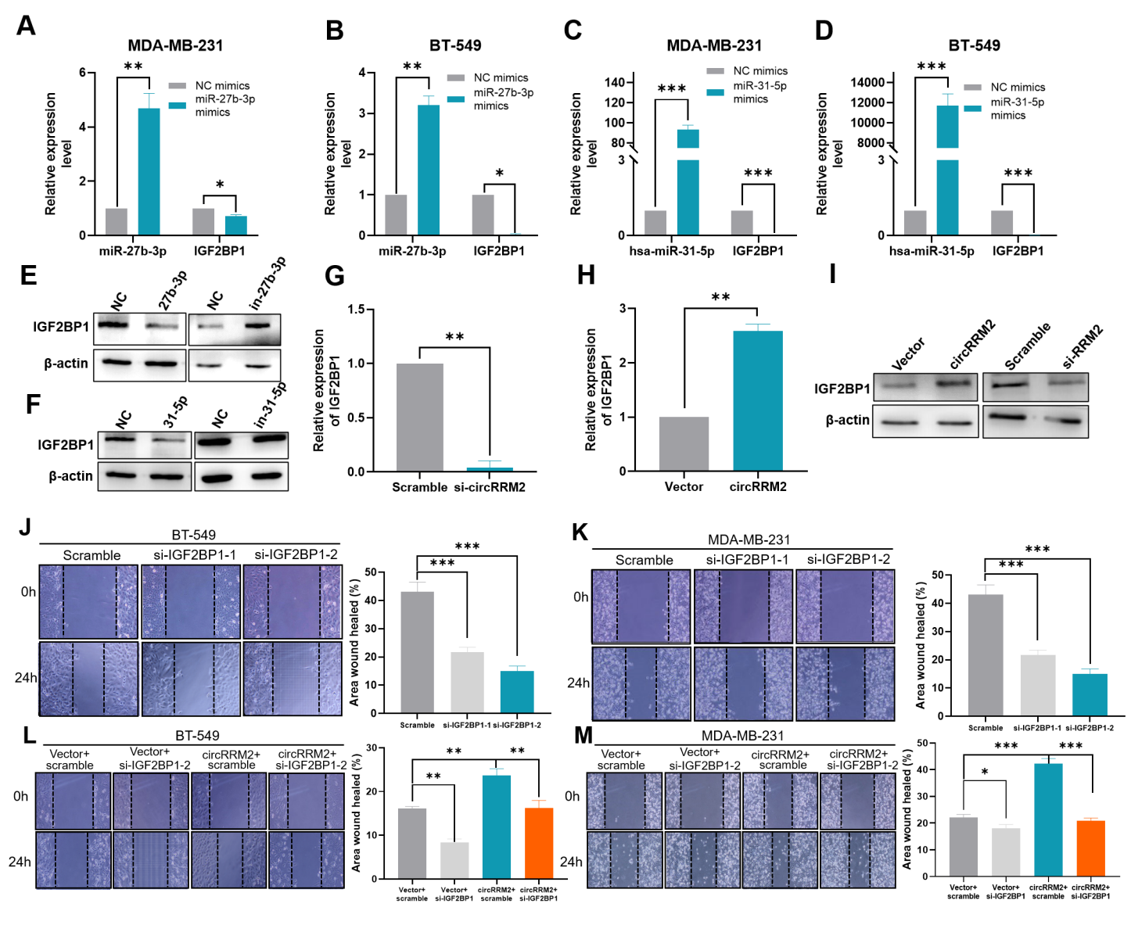

Figure 9. IGF2BP1 is the target gene of miR-27b-3p/miR-31-5p regulated by circRRM2.

Alterations in the mRNA levels of miR-27b-3p and IGF2BP1 in BT-549 (A) or MDA-MB-231(B) cells following miR-27b-3p overexpression. Alterations in the mRNA levels of miR-31-5p and IGF2BP1 in BT-549 (C) or MDA-MB-231(D) cells following miR-31-5p overexpression. The protein level of IGF2BP1 in the cells following the overexpression and knockdown of miR-27b-3p (E) / miR-31-5p (F) was examined by western blotting. Silencing or overexpression circRRM2, the expression of IGF2BP1 mRNA (G-H) and protein (I) was assessed by qRT-PCR and WB, respectively. Scratch wound healing assay showed the migration ability of IGF2BP1 silencing in BT-549 (J) or MDA-MB-231 (K) cells. The rescue effect of overexpression of circRRM2 on IGF2BP1 knockdown in BT-549 (L) or MDA-MB-231 (M) cells was investigated.

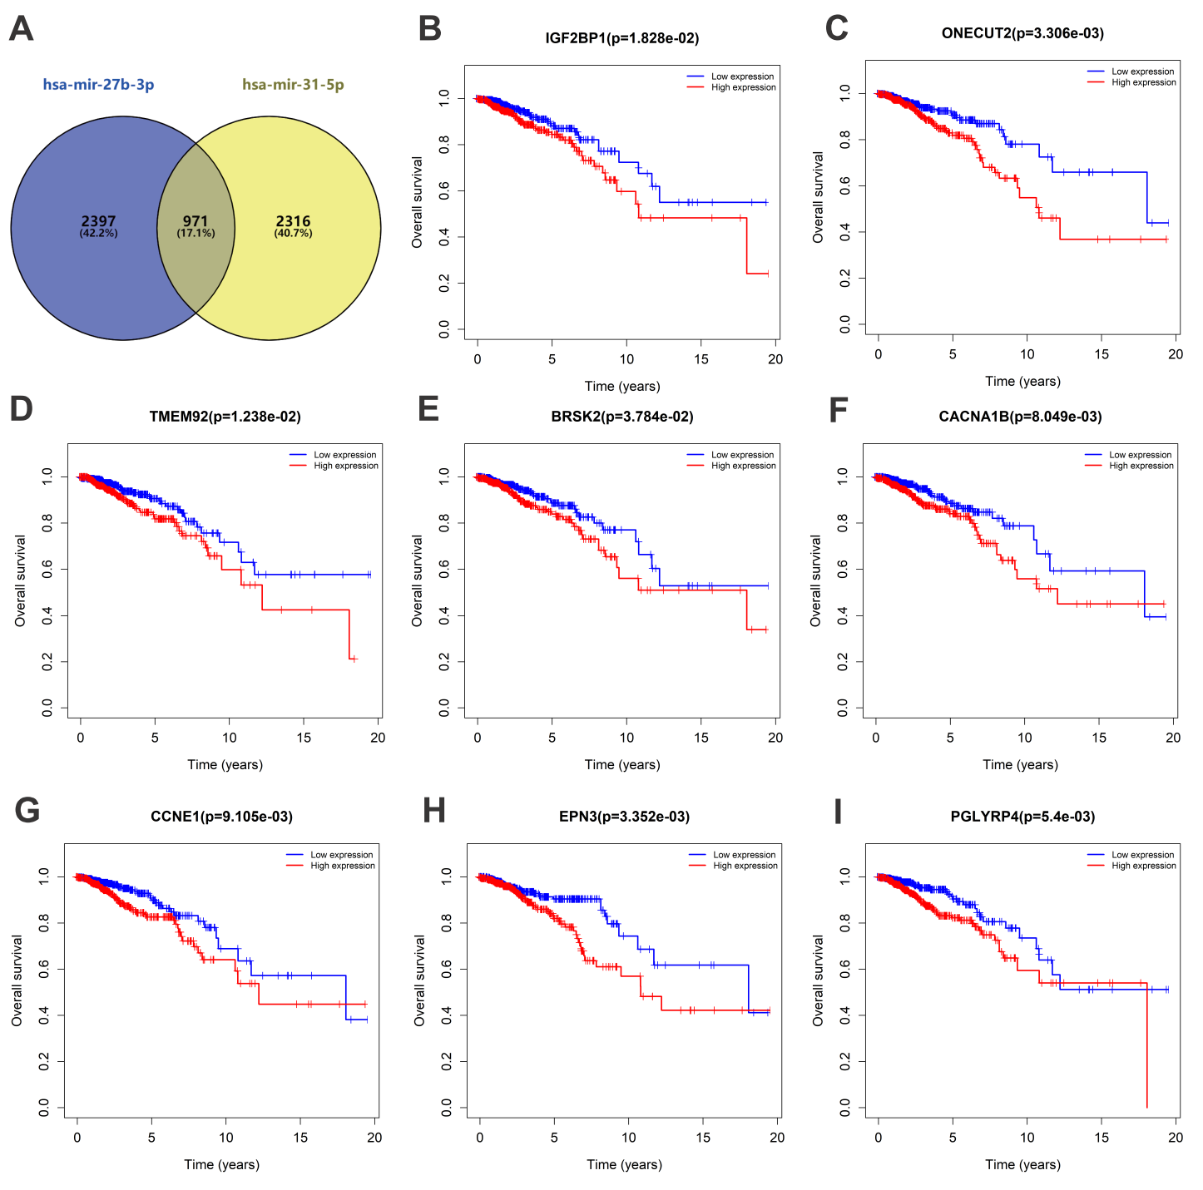

Figure S5. Prediction and prognostic value of target genes binding with both miR-27b-3p and miR-31-5p

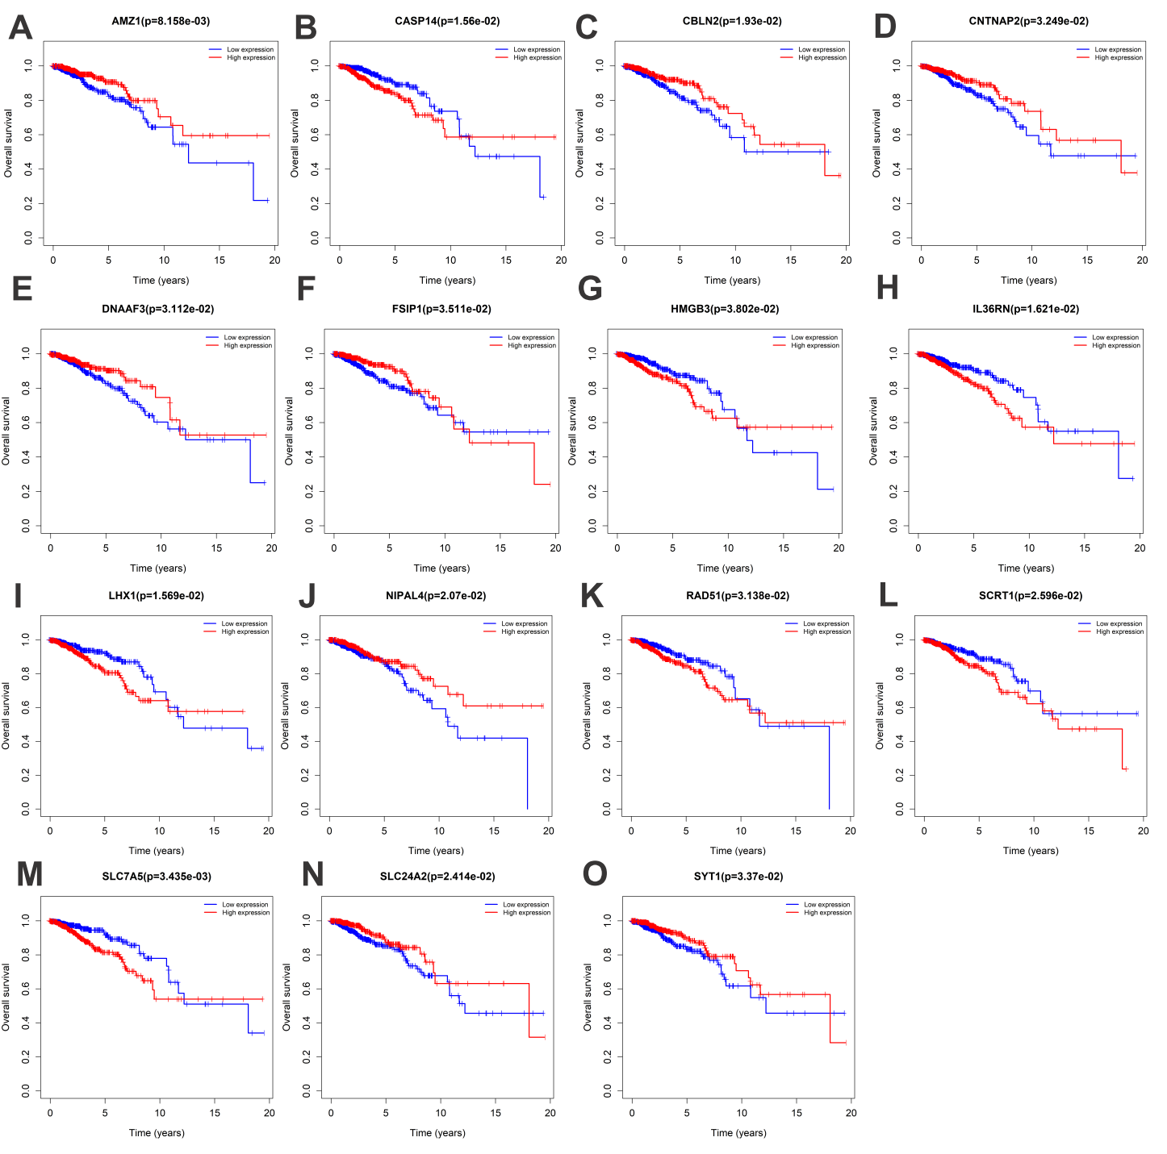

Figure S6. Prognostic value of target genes binding with both miR-27b-3p and miR-31-5p

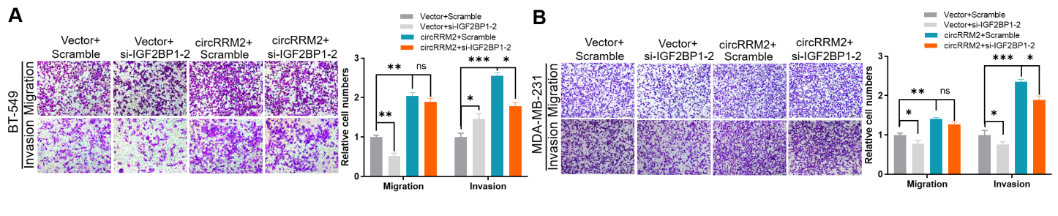

Figure S7. The transwell assay in BC cell transfected with circRRM2 plasmid and IGF2BP1 siRNA.

The transwell assay was performed, to detect the rescue effect of overexpression of circRRM2 on IGF2BP1 knockdown in BT-549 (A) or MDA-MB-231 (B) cells.

**3.9 Upregulated IGF2BP1 promotes BC progression.**

The TCGA-BRCA dataset was downloaded to explore the clinical significance of IGF2BP1 mRNA expression. IGF2BP1 was demonstrated to be significantly upregulated in BC tissues (n=1109) compared to that of normal tissues (n=113) (P<0.001, Figure 10A), and its level was also higher compared with normal breast samples (n=179) from GTEX databases (P<0.001, Figure 10B). Using the TCGA paired sample dataset (n=112), we identified that IGF2BP1 expression was significantly upregulated in BC tissues (P<0.001, Figure 10C). The expression of IGF2BP1 was found to be significantly upregulated in BC patients at T3/T4 stage compared with those at T1/T2 stage (P<0.001, Figure 10D), and its level was much higher in ductal invasive tissues (P<0.001；Figure 10E). The tumor samples of PR negative (P<0.001, Figure 10F), ER negative (P<0.001, Figure 10G), or HER2 positive (P<0.001, Figure 10H) also possessed higher levels of IGF2BP1. We also compared the expression of IGF2BP1 among PAM50 subtypes, and found that its level was upregulated in all the subtypes, especially the basal group (Figure 10I). Importantly, we validated the expression level of IGF2BP1 by IHC assay in 40 BC patients, and IGF2BP1 was expressed at a higher level in the high-circRRM2 group (Figure 10J-K).

ROC curve based on IGF2BP1 level showed the moderate accuracy to discriminate the outcome of normal or cancer (AUC = 0.766, CI = 0.730-0.802, Figure 10L). Survival curves were plotted using the Kaplan-Meier method, and patients with high IGF2BP1 had a worse OS (P = 0.029, Figure 10M) compared with low IGF2BP1 group. We performed the LASSO regression analysis for screening the coefficients associated with the OS of BC patients (Figure 10N), and the trajectories of variables were plotted in Figure 10O. Finally, the significant variables, including IGF2BP1 level, T stage, PR status, ER status, HER2 status, and PAM50 subtype, were included as candidates in the nomogram. The risk score calculated by the nomogram could predict the probability of OS for BC patients. In addition, the calibration curve was also plotted to measure the performance of the nomogram, which showed its predictive power was moderate (C-index=0.669, Figure S8).

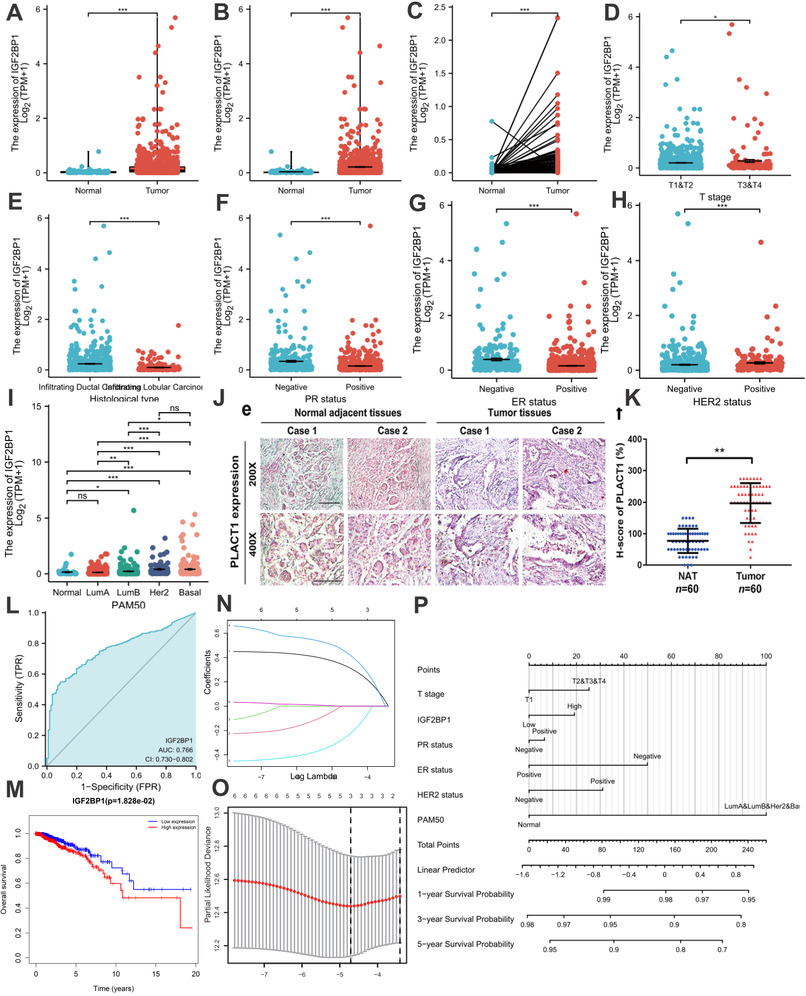

Figure 10. Analysis of clinical significance of IGF2BP1

(A) The differential expression of IGF2BP1 in BC samples (n=1109) and normal samples collected by TCGA databases (n=113). (B) Comparison of IGF2BP1 in BC samples (n=1109) and normal samples collected by TCGA (n=113) and GTEX databases (n=179). (C) Comparison of IGF2BP1 in BC samples (n=112) and paired normal samples (n=112) collected by TCGA databases. (D) The differential expression of IGF2BP1 in T1/T2 group (n=906) and T3/T4 group (n=174) collected by TCGA databases. (E) The differential expression of IGF2BP1 in infiltrating ductal carcinoma (n=772) and infiltrating lobular carcinoma (n=205) collected by TCGA databases. Analysis of IGF2BP1 expression level in BC tissues with different status of PR (F), ER (G), and HER2 (H). (I) The expression of IGF2BP1 among PAM50 subtypes. (J) Representative IHC pictures of IGF2BP1 in BC tissues. (K) Comparison of IHC scores of IGF2BP1 between circRRM2-low (n=20) and circRRM2-high group (n=20) in BC patients. (L) ROC curves based on IGF2BP1 level to discriminate between normal and cancer in BC patients. (M) The KM curve for OS in BC patients with high vs. low IGF2BP1 expression levels. (N) LASSO regression analysis for screening coefficients in predicting OS for BC patients. (O) The plot of trajectories of variables for predicting the probability of OS for BC patients. (P) Nomogram for predicting the 1-, 3‐ or 5‐year OS time in patients.

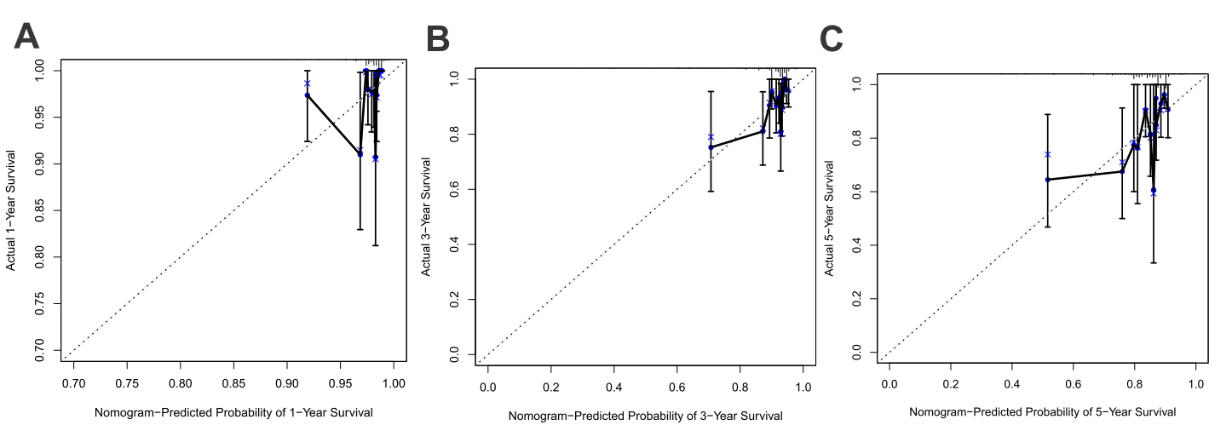

Figure S8. Calibration plot of the nomogram for predicting the probability of OS at 1, 3, and 5 years.

**3.10 Analysis of immune cells infiltration related to IGF2BP1 in BC patients.**

We performed the ssGSEA to analyze the immune infiltration for 24 types of immunocytes in BC between IGF2BP1-high and IGF2BP1-low expression group. The result demonstrated that IGF2BP1 expression presented a variety of correlation to immune cell infiltration (Figure 11A) IGF2BP1 high expression was positively associated with the infiltration of macrophages, Th1 cells, and Th2 cells, and negatively with NK CD56 bright cells, eosinophilia, and mast cells (Figure 11A). We further found that IGF2BP1 expression positively related to the infiltration of B cells, T cells, and macrophages in BC patients using TIMER platform (Figure 11C). Besides, higher level of B cells infiltration predicted better prognosis in OS of BC patients (Figure 11D). Based on IGF2BP1 status of copy number variation using TIMER, we divided the BC patients into five groups, including deep deletion, arm-level deletion, diploid/normal, arm-level gain, and high amplification. We identified that the levels of B cells, CD8+T cells, CD4+T cells, macrophages, neutrophils, and dendritic cells presented significant down-regulation in arm-level deletion group (Figure 11E). Moreover, the correlation between the IGF2BP1 expression level and checkpoint-related genes was observed (Figure 11B). In BC patients, those with high expression of IGF2BP1 had significantly higher level of CD274, CTLA4, HAVCR2, LAG3, PDCD1, PDCD1LG2, and TIGIT (Figure 11B).

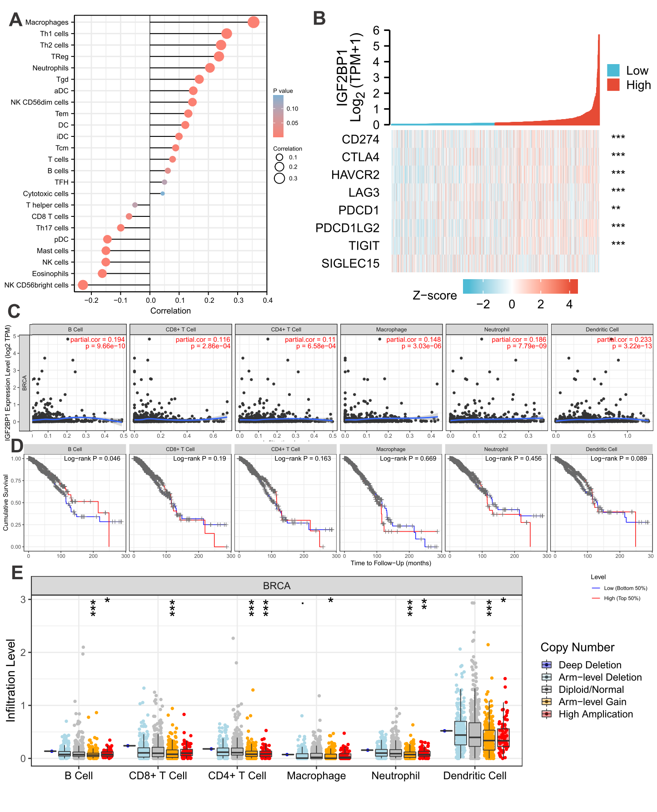

Figure 11. Analysis of immune cells infiltration related to IGF2BP1 in BC patients.

(A) Lollipop plot shows the correlation between IGF2BP1 level and immunocytes infiltration. (B) Correlations between IGF2BP1 and immune checkpoint-related genes. (C) Scatter plot of correlation between IGF2BP1 and immunocytes infiltration. (D) KM curve of immunocytes infiltration status and OS in BC patients. (E) Comparison of immunocytes infiltration related with copy number variation of IGF2BP1.

**3.11 Methylation and mutational analysis of IGF2BP1.**

We also explored the levels of DNA methyltransferase related to IGF2BP1 by analyzing the TCGA-BRCA dataset. The levels of DNMT1, DNMT3A, and DNMT3B were all upregulated in IGF2BP1-high group (Figure 12A-C). UALCAN was adopted to compare the methylation level between normal and BC patients, and down-regulation of methylation level was observed in BC patients (P<0.001, Figure 12D). Subsequently, we confirmed that the level of methylation in IGF2BP1 promoter decreased in BC patients compared with control subjects (P<0.001, Figure 12E). The DNA methylation sites of IGF2BP1 were obtained using MEXPRESS, and multiple sites were negatively associated with IGF2BP1 expression (i.e., cg05370977 and cg23596986, Figure 12F).

Using the cBioPortal database, we analyzed the characteristic of missense mutation and PTM sites located in IGF2BP1 in BC samples (Figure S9). The results exhibited that amplification was the predominant mutation type, and covered 6% of the entire protein length (Figure S9A). The TMB score was 264, and the MSI mantis score ranged 0.22 to 0.83 (Figure S9A). The high-frequency mutation site was A240T located at KH-1 domain of IGF2BP1, and multiple phosphorylation and acetylation sites were prevalent in the IGF2BP1 amino acid sequence (Figure S9B).

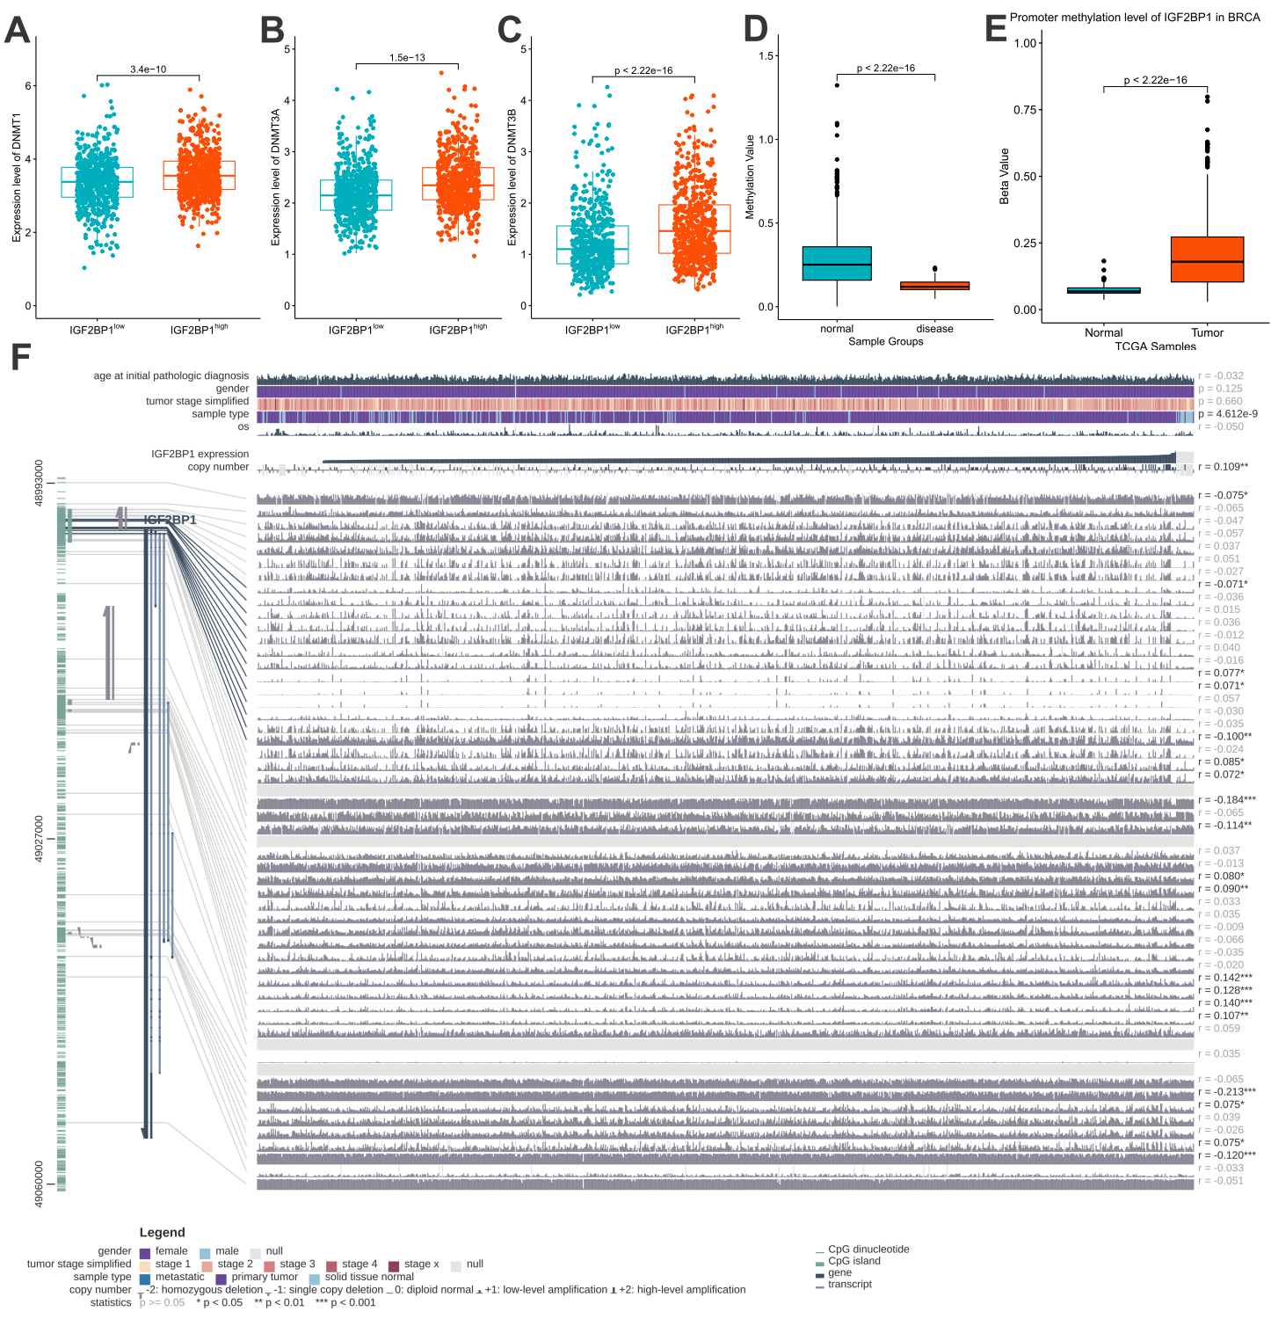

Figure 12. Methylation analysis of IGF2BP1.

Comparison of expression level of DNMT1 (A), DNMT3A (B), and DNMT3B (C) between IGF2BP1-high and IGF2BP1-low BC patients. (D) Analysis of levels of methylation in BC patients. (E) DNA methylation analysis of the IGF2BP1 promoter region. (F) DNA methylation sites in IGF2BP1.

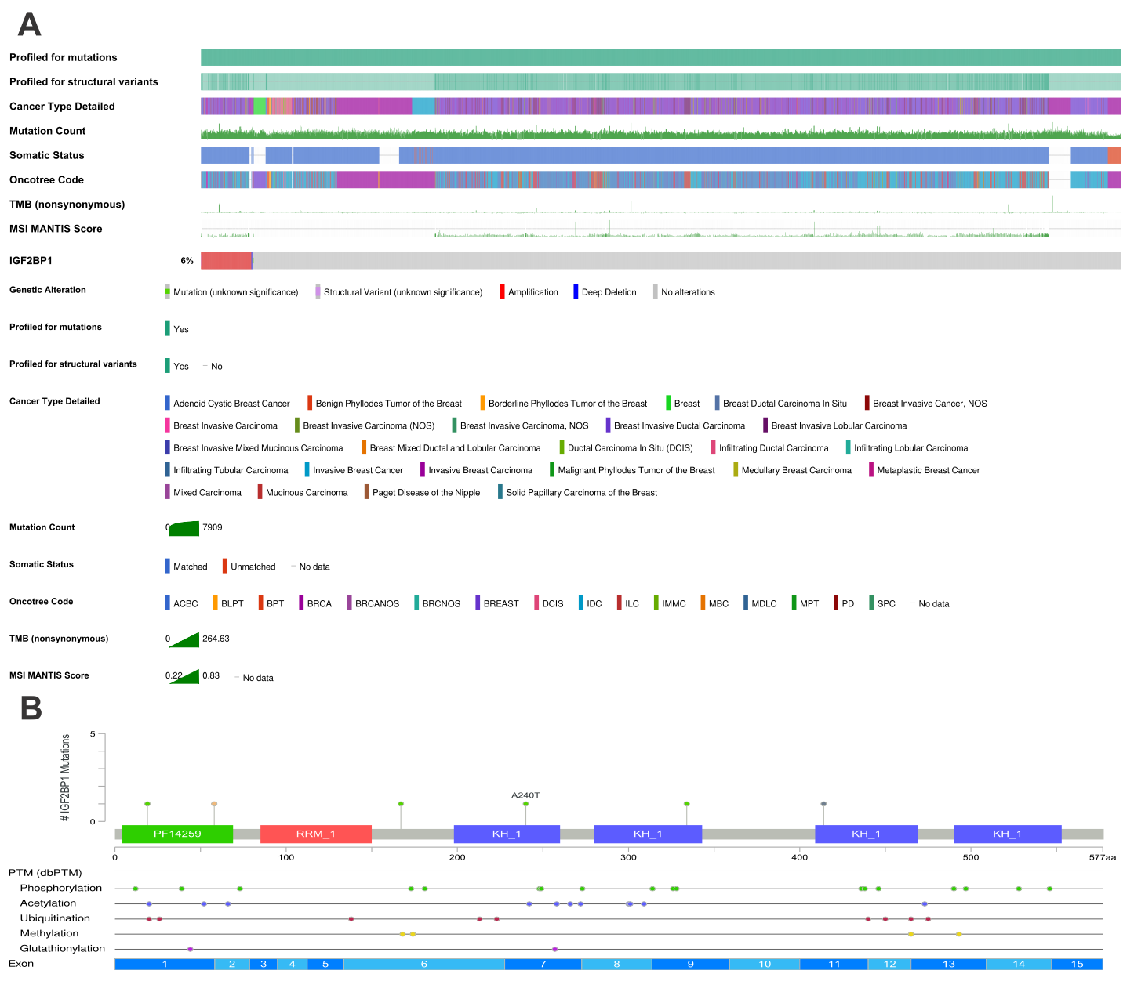

Figure S9. Mutational analysis of IGF2BP1.

(A) The oncoprint of IGF2BP1 was obtained using cBioPortal. (B) Analysis of PTM sites in IGF2BP1.

**3.12 The mechanism of positive feedback loop of circRRM2/IGF2BP1/MYC.**

To explore the upstream regulators of circRRM2, we obtained 1000bp sequence upstream of circRRM2 transcription start site (TSS) to conduct further analysis. Then, the candidate transcriptional factors were identified as MYC, JUNB, and CTCF, by the database JASPAR (Figure 13A). We observed that circRRM2 was down-regulated after decreasing of MYC (Figure 13B), JUNB (Figure 13C), or CTCF (Figure 13D), respectively. Meanwhile, the migration ability of BC cells was significantly restrained, as the level of MYC (Figure 13E/H), JUNB (Figure 13F/I), or CTCF (Figure 13G/J) was decreased. Interestingly, when the cells were transfected with IGF2BP1 siRNA, the level of circRRM2 was also reduced significantly (Figure 13K-L). The levels of MYC, JUNB, and CTCF were also reduced with concomitant decreases in IGF2BP1expression (Figure 13M-O). Above results suggested that IGF2BP1 positively regulated the expression of circRRM2 through interacting with MYC/JUNB/CTCF. Then, we noted that MYC was one of candidates which bound to IGF2BP1 predicted by BioGRID (Figure S10). CoIP and WB experiments were performed to detect the binding of MYC to IGF2BP1. As expected, a significant enrichment of MYC with IGF2BP1 antibody was observed when compared with the IgG antibody (Figure 13P). Our results illustrated that IGF2BP1 upregulated the transcriptional activation of circRRM2 via interacting with MYC, which lead to a rise in IGF2BP1 level (Figure 13Q). Therefore, circRRM2/IGF2BP1/MYC formed a positive feedback loop and facilitated the invasion behavior of cancer cells.

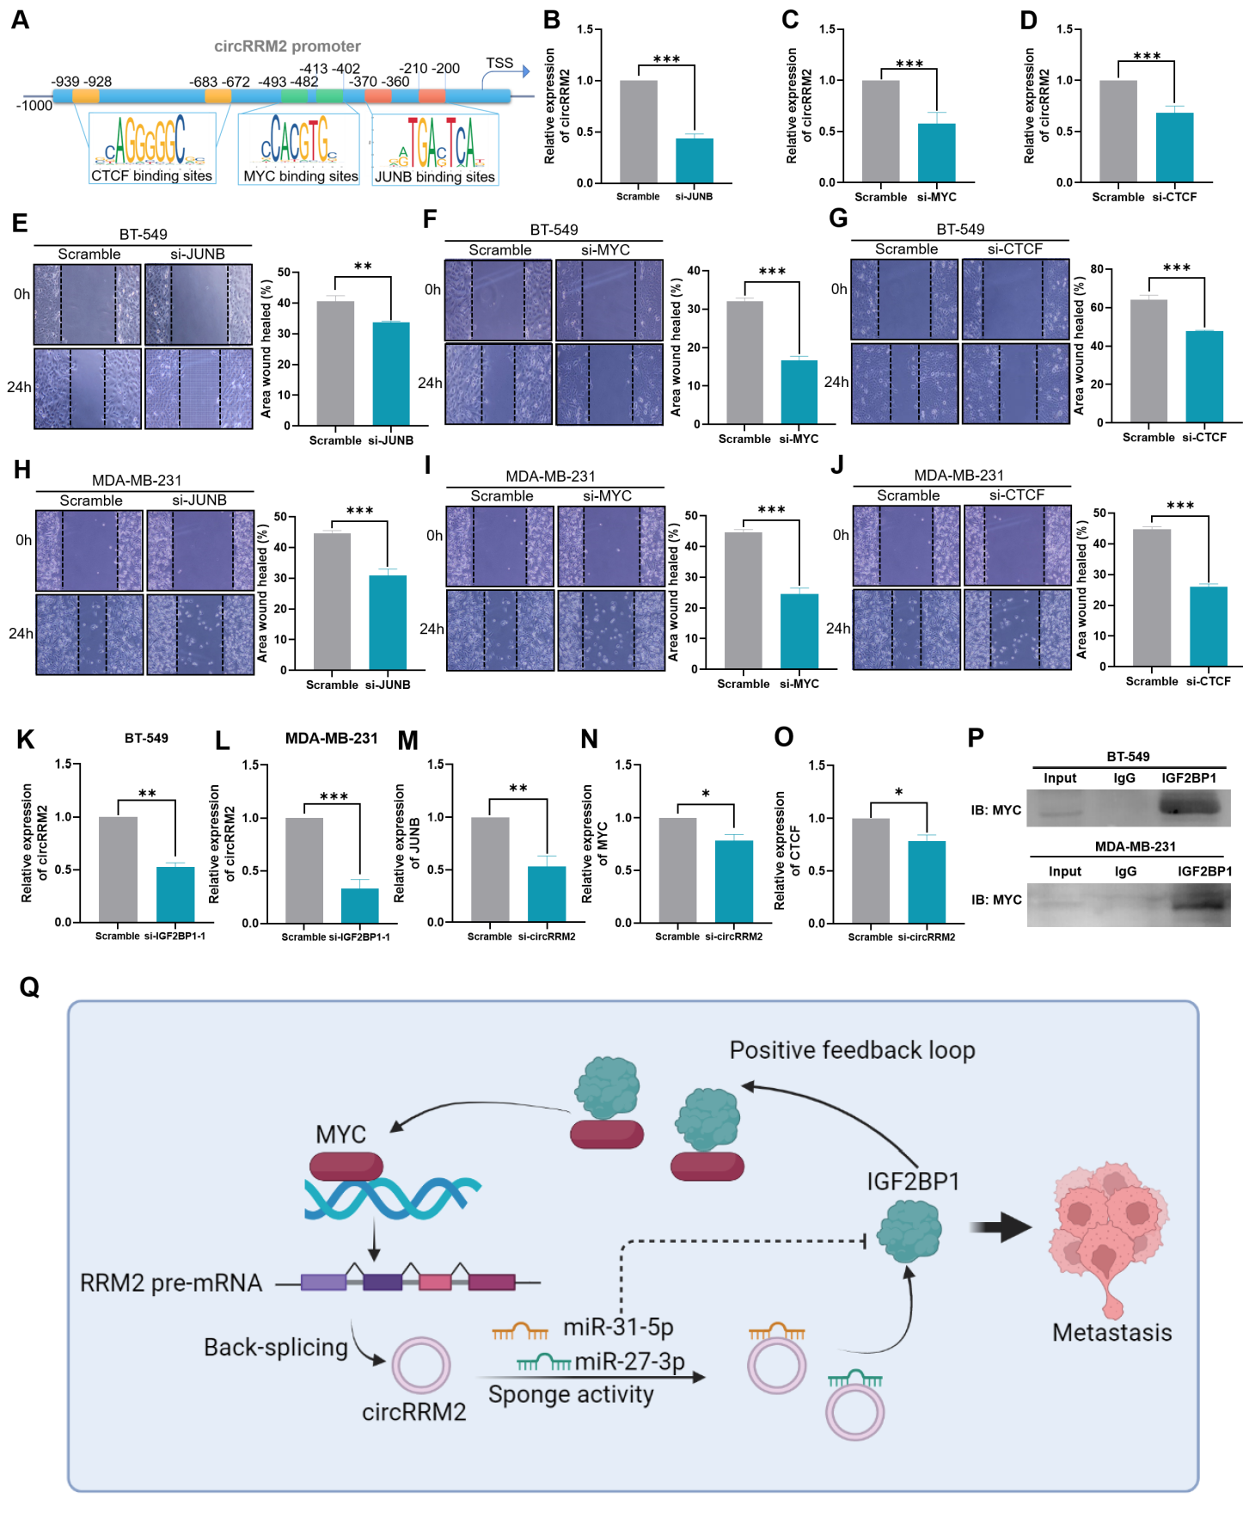

Figure 13. Validation the function of MYC as transcription factor of circRRM2 and positive feedback loop of circRRM2/IGF2BP1/MYC.

(A) Schematic of transcription factor binding sites of the circRRM2 promoter. qRT-PCR results of circRRM2 level in BT-549 cells after silencing MYC (B), JUNB (C), or CTCF (D). A scratch wound healing assay was performed to determine the cell migration ability of CRC cells after silencing MYC (E/H), JUNB (F/I), or CTCF (G/J). The relative expression of circRRM2 after silencing IGF2BP1 in BT-549 (K) or MDA-MB-231 (L) cells. The relative expression of MYC (M), JUNB (N), or CTCF (O) after silencing IGF2BP1 in BT-549 cells. (P) CoIP and WB experiments to detect the binding of MYC to IGF2BP1. (Q) Diagram illustrating the proposed mechanism of positive feedback loop of circRRM2/IGF2BP1/MYC.

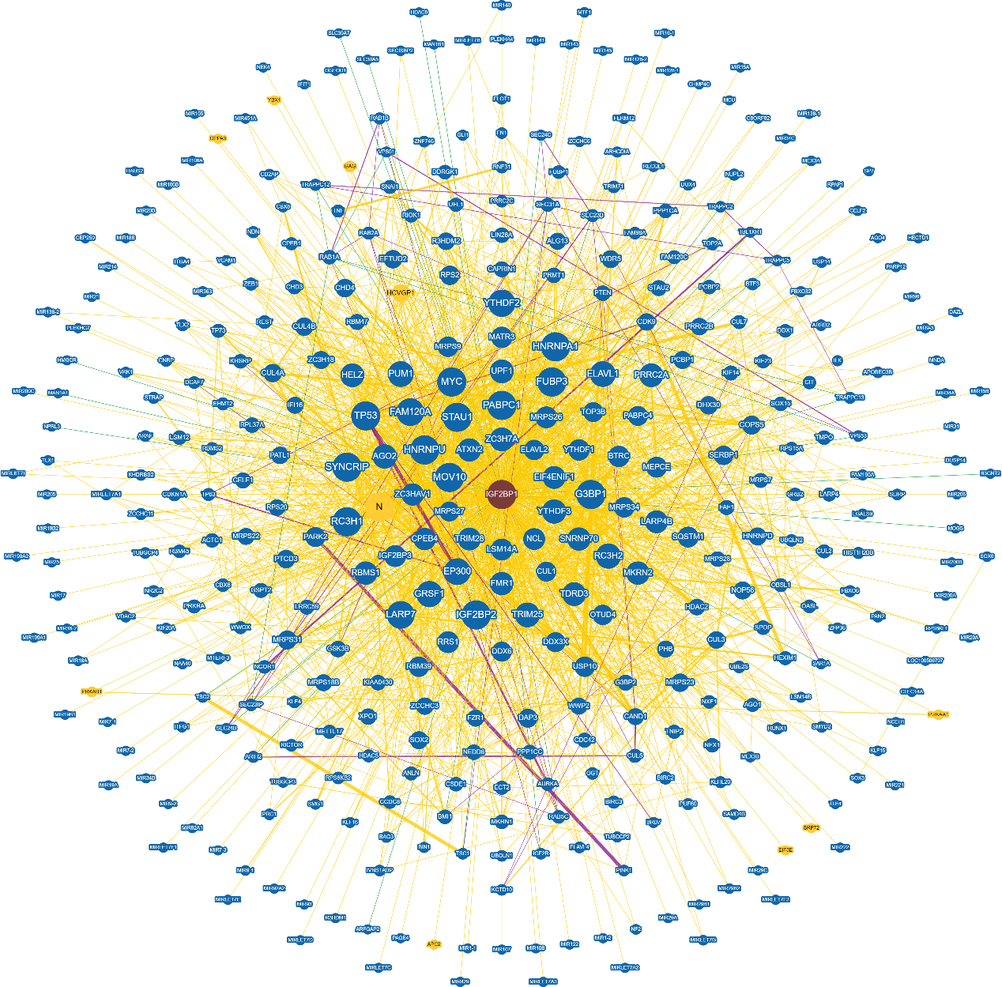

Figure S10. Network of candidates binding to IGF2BP1 constructed using the BioGRID database.

**4. Discussion**

In this study, a number of dysregulated circRNAs in BC compared with adjacent normal tissues. were identified. Here, we identified that circRRM2 was upregulated in BC tissues, and was capable of promoting the migration and invasion BC cell lines. Further studies showed that circRRM2 exerts its regulatory functions through competing with miR-31-5p/miR-27-3p to drive the expression of IGF2BP1. Rescue assays demonstrated that circRRM2 knockdown can partially reverse the facilitation effect of overexpressed IGF2BP1 on the migration of BC cells. Importantly, IGF2BP1 upregulated the level of circRRM2 via interacting with MYC, which lead to a rise in IGF2BP1 level. Therefore, circRRM2/IGF2BP1/MYC formed a positive feedback loop and facilitated the metastasis of BC patients.

The functions of circRNAs are related to their subcellular localization [Ref]. In the cytoplasm, circRNAs frequently exert their functions by sponging miRNAs [Ref]. In this study, circRRM2 was detected in both nucleus and the cytoplasm of BC cells (Figure 4E). Ago2 is the key component of RISC involved in the ceRNA mechanism [Ref], and anti‐Ago2 antibody was able to enrich circRRM2 by RIP assays (Figure 7A). The above results further confirmed that circRRM2 could function via miRNA binding. Subsequently, we performed the bioinformatics analysis and found that circRRM2 might bind to miR-27b-3p or miR-31-5p (Figure 7B). The mRNA level of miR-27b-3p or miR-31-5p increased significantly in circRRM2-knockdown cells (Figure 7C and 7D). We also observed the co-localization between circRRM2 and miR-27b-3p in cytoplasm by FISH experiment (Figure 7E). The KM curves indicated that the low miR-31-5p group was associated with poorer OS using TCGA-BRAC datasets (Figure 7G). Previous study showed that miR-31-5p was significantly down-regulated in renal cell carcinoma (RCC) tissues and its downregulation was associated with poor prognosis in RCC patients [PMID: 30597305]. The finding is consistent with our results. We subsequently assessed the invasive phenotype of miR-27b-3p or miR-31-5p transfecting its mimics or inhibitor into BC cells, and found that both miR-27b-3p and miR-31-5p exerted a tumor-suppressor on BC (Figure 8 and S4). This trend is consistent with those reported in previous studies [PMID: 29796229, 34126594, 29416005]. Further rescue experiment elucidated that circRRM2 significantly attenuated the effects of miR-873-3p on BC cell invasive ability (Figure 8 and S4). These results suggested that circRRM2 may exert its biological functions through ceRNA mechanism in BC.

Subsequently, we identified IGF2BP1 as the candidate of miR-31-5p/miR-27-3p target gene for its upregulated expression associated with poor OS in BC patients (Figure S5B). When miR-27b-3p or miR-31-5p was overexpressed, the mRNA levels of IGF2BP1 were downregulated in BC cells (Figure 9A-D). The protein level of IGF2BP1 was suppressed by the mimics of miR-27b-3p but not miR-31-5p (Figure 9E-F). The possible reason is that miR-27b-3p might involve in the post-transcriptional processing of IGF2BP1. IGF2BP1 is a member of the insulin-like growth factor 2 mRNA-binding protein family [PMID: 29954406]. The protein encoded by this gene contains four K homology domains and two RNA recognition motifs (RRM) [Ref]. It functions by binding to the mRNAs of certain genes, including insulin-like growth factor 2, beta-actin repeat-containing protein, and regulating their translation [Ref]. In breast cancer cells, IGF2BP1 is necessary for clonogenic activity and its function is served by either the full-length IGF2BP1 or the N-terminally truncated version [PMID: 25861986]. Besides, IGF2BP1 enhances the stability of MIR210HG, which functions as an oncogenic lncRNA, and contributes to the progression of breast cancer [PMID: 35346372]. In our study, similar results were obtained that treatment with siRNA of IGF2BP1 reduced the migratory ability of BC cells (Figure 9J-K). We also executed the rescue experiment, and results demonstrated that circRRM2 knockdown can partially reverse the facilitation effect of overexpressed IGF2BP1 on the migration or invasion of BC cells (Figure 9L-M, Figure S7). These results suggested that circRRM2 may function as a ceRNA to regulate IGF2BP1 in BC.

Additionally, we explored the role of IGF2BP1 in BC clinical significance and infiltrating immune cells in the tumor microenvironment through bioinformatic analysis. IGF2BP1 expression was significantly upregulated in BC tissues (Figure 10A-C). The high level of IGF2BP1 was found to be positively associated with high T stage, PR negative, ER negative, or HER2 positive in BC patients (Figure 10D, F and G). We also validated that IGF2BP1 was expressed at a higher level in the high-circRRM2 group by IHC assay in 40 BC patients (Figure 10J-K). The accuracy of ROC curve was 0.766 which indicated that the discriminatory ability for BC from normal by IGF2BP1 level was moderate (Figure 10L). Patients with higher IGF2BP1 had a worse OS using the Kaplan-Meier method (Figure 10M). The above results demonstrated that IGF2BP1 was an oncogene in BC. Previous studies identified that IGF2BP1 promoted tumor progression contributing to tumor cell proliferation, growth, migration, and invasion, and upregulated IGF2BP1 was associated with a poor overall survival and metastasis in various types of human cancers (PMID: 23069990, 29954406, 34203267). Thus, our results further proved the above conclusions. Besides, IGF2BP1 expression positively related to the infiltration of B cells, T cells, and macrophages, and also associated with checkpoint-related genes in BC patients (Figure 11A and C). IGF2BP1 could function as a m6A reader and enriched the 3'-UTR of immune checkpoint PD-L1 mRNA, thus enhanced the mRNA stability of PD-L1 in bladder cancer [PMID: 35502544]. It might could be the interpretation of our results.

MYC is a proto-oncogene and plays an important role in cell cycle progression, apoptosis and cellular transformation [Ref]. The complex formed by MYC and its related transcription factor MAX, binds to the E box DNA consensus sequence and regulates the transcription of specific target genes [Ref]. In cancer, MYC could bind to the VEGFA promoter, promoting VEGFA production and subsequent sprouting angiogenesis [PubMed:24940000, 25956029]. The present study identified that two MYC transcription factor binding sites were present in the promoter of circRRM2 (Figure 13A), and circRRM2 was down-regulated after MYC in BC cells (Figure 13B). Thus, we speculated that MYC may contribute to the transcriptional activation of circRRM2. Interestingly, we also found that MYC was one of candidates which bound to IGF2BP1 predicted by BioGRID (Figure S10), and the binding of MYC to IGF2BP1 was validated by CoIP and WB experiments (Figure 13P). Previous study reported that IGF2BP1 could retain the stability of MYC mRNA in BC cells, through increasing binding of IGF2BP1 with the m6A-modified MYC mRNA of coding region instability determinant (CRD) [PMID: 33469161, 30771425]. This could explain the interaction mechanism between IGF2BP1 and MYC and the downstream effects, and further investigations is required in our study. Moreover, when the cells were transfected with IGF2BP1 siRNA, the level of circRRM2 was reduced significantly (Figure 13K-L). The levels of MYC were also reduced with degression of IGF2BP1 level (Figure 13N). Above results suggested that IGF2BP1 positively regulated the expression of circRRM2 through interacting with MYC/JUNB/CTCF. Therefore, we hypothesized that circRRM2/IGF2BP1/MYC formed a positive feedback loop and promoted the BC metastasis.

There were some limitations of our study. First, the role of circRRM2 in promoting cancer metastasis was not validated with animal experiments. Second, the miRNA binding sites with circRRM2 or IGF2BP1, were predicted using bioinformatics method, which need to be validated experimentally. Third, how IGF2BP1 interacts with MYC and regulates the level of circRRM2 in BC progression still needs further investigation, and we will continue to focus on this issue in our future studies.

In conclusion, our results suggest that upregulated circRRM2 functions an oncogenic role in BC metastasis. circRRM2 competitively binds miR-31-5p/miR-27-3p to abolish the suppressive effect on IGF2BP1, then promotes BC cell migration and invasion. The results reveal that a feed-forward loop of circRRM2/IGF2BP1/MYC enforced the expression of circRRM2. Our study may provide an insight into understanding of the molecular mechanism of BC metastasis, and a potential therapeutic approach for BC.